|  |  |
| --- | --- |
|  | **VIỆN ĐÀO TẠO QUỐC TẾ FPT**  **LẬP TRÌNH VIÊN QUỐC TẾ** **FPT - APTECH** |

**Centre Name: ACE-HCMC-2-FPT.**

**Address: 590 Cach Mang Thang 8, District 3, Ho Chi Minh City, Viet Nam.**

**OTAKOOL**

|  |  |  |
| --- | --- | --- |
| **Supervisor** | Ms.Đào Ngọc Anh | |
| **Batch** | T1.2109.E0 | |
| **Group** | Group 3 | |
| **Serial No.** | **Enrollment Number** | **Student Name** |
| 1. | Student1319917 | Đào Bùi Quang Hưng |
| 2. | Student1320854 | Nguyễn Hoài Thương |
| 3. | Student1317115 | Nguyễn Ngọc Kim Ngân |
| 4. | Student1333969 | Lã Bảo Minh |

Table of Contents

**REVIEW 1** 5

I. PROBLEM STATMENT: 6

II. ASSESSING THE CURRENT TREND: 6

III. DETERMINING THE CUSTOMER’S REQUIREMENTS: 6

IV. INPUT AND OUTPUT SYSTEM: 6

V. SYSTEM REQUIREMENTS: 10

VI. SCOPE: 11

Task Sheet Review 1 11

**REVIEW 2** 12

Project Design 13

I. PROBLEM STATMENT: 14

1. Otakool Map: 15

2. Data Flow Diagram: 15

Admin DFD: 15

Promotion DFD: 16

Product DFD: 16

Order DFD: 16

Comment DFD: 16

Customer DFD: 17

Feedback DFD: 17

News DFD: 18

News Category DFD: 18

Q&A (Question and Answer) DFD: 18

Contact DFD: 19

II. DATABASE DESIGN: 20

3. Entity Relation Diagram (ERD): 20

4. Entity Description: 20

5. Database Relation Diagram (DRD): 24

6. Database Structure: 25

III. SITEMAP: 28

1. Customer sitemap 28

2. Admin sitemap 29

Task Sheet Review 2 30

**REVIEW 3** 31

A – Customer Pages 32

1. Header: 32

2. Footer: 32

3. Home page: 33

4. Register page: 35

5. Login page: 36

6. My Profile: 37

7. Edit My Profile: 38

8. My orders: 39

9. Change customer password: 39

10. Product pages (Manga/Anime/Figure/Merchandise): 40

11. Promotions: 41

12. Search: 42

13. Product details: 43

14. Shopping Cart: 44

15. Check out page: 44

16. Feedback: 45

17. News page: 46

18. News details: 47

19. Contact page: 48

20. Q&A page: 49

B – Admin Pages 49

1. Login: 49

2. Back end index: 50

3. Admin management: 52

4. Register an admin: 53

5. Admin profile: 54

6. Edit admin profile: 55

7. Change admin password: 56

8. Customer Management: 57

9. Customer Profile: 57

10. Edit Customer Profile: 58

11. Product List: 59

12. Product – create: 60

13. Product – View: 61

14. Product Edit: 63

15. Order page: 65

16. Order details: 65

17. Order Update 66

18. Comment list: 67

19. Feedback: 67

20. Promotion Management: 68

21. Promotion create: 69

22. Promotion view: 70

23. Promotion edit: 71

24. News: 72

25. News - Create: 73

26. News - view: 74

27. News - Edit: 75

28. Contact Management: 76

29. Q&A Management: 76

30. Q&A Create: 77

31. Q&A Details 77

32. Q&A – Edit 78

33. Print invoice 79

Task Sheet Review 3 80

# REVIEW 1

# PROBLEM STATMENT:

* The internet has changed the way we work, socialize, create, and share information. Moreover, it fulfills customers’ demands through ease of access; buyers need not worry about traveling long distances to search for the items they want or to see if they are available. Companies now have more ways of reaching more consumers through many internet channels.
* Therefore, we have decided to build an online shopping website named Otakool dedicated to creating the most convenient way for customers to purchase products related to Japanese entertainment culture.

# ASSESSING THE CURRENT TREND:

* An **otaku** is a person having a fascination with Japanese animations – anime – and comics – manga. With the rising popularity of Japanese Otaku culture in Vietnam, many people, especially the young, want to be able to get the latest manga, anime, figures, and merchandise. Thanks to the internet, we can make these products more accessible for everyone.
* Launching the shopping website – [www.otakool.com](http://www.otakool.com) – is to overcome the obstacles that prevent otakus from getting the products they want. Customers can find, view, and order products related to the anime or manga that they enjoy. They can also rate the shop’s products and provide feedback. Additionally, they can have a look at the latest anime product, receive offers, and subscribe to become Otakool’s members.

# DETERMINING THE CUSTOMER’S REQUIREMENTS:

* Customers coming to the website can perform the following functions: view all anime character-related products, view latest products and promotional products. Customers can search by product name and product group: manga, anime-disc, figures, and merchandise. In addition, view products details, review products, purchase products, view store’s address, view store’s information, view purchase history, view contact, Q&A and website feedback. Customers can get a discount when registering an account and edit personal information.
* The website administrator page has the following main functions:
  + Main management: create administrator roles, manage customers, news, feedbacks, contacts and Q&A, view products, orders and total revenue, and manage the system client. Main management can also do all the functions that product management and order management can.
  + Product management: create, view, edit, delete products, and manage comments, manage promotions.
  + Order management: view orders, process orders and calculate revenue.

# INPUT AND OUTPUT SYSTEM:

1. **Customer**

|  |  |  |
| --- | --- | --- |
| **Input** | **Process** | **Output** |
| - Customer:   * View products by category, latest product, promotion product. * Search product by name, tags, rating. * View product details and rate it. * Leave product reviews on the website. * Purchase product. * Create an account to become a member. * Feedback about the website. * View store’s news. * View Q&A * View store contact information. | - Processing on the database to get the necessary data and check the customer's registered information. | - Output:   * List of products by category. * Product details, customer’s product reviews. * Purchase order information. * Information on registered customers. * Content of comments, news and feedback. * Introduction of store. |

**Function Customer Diagram**

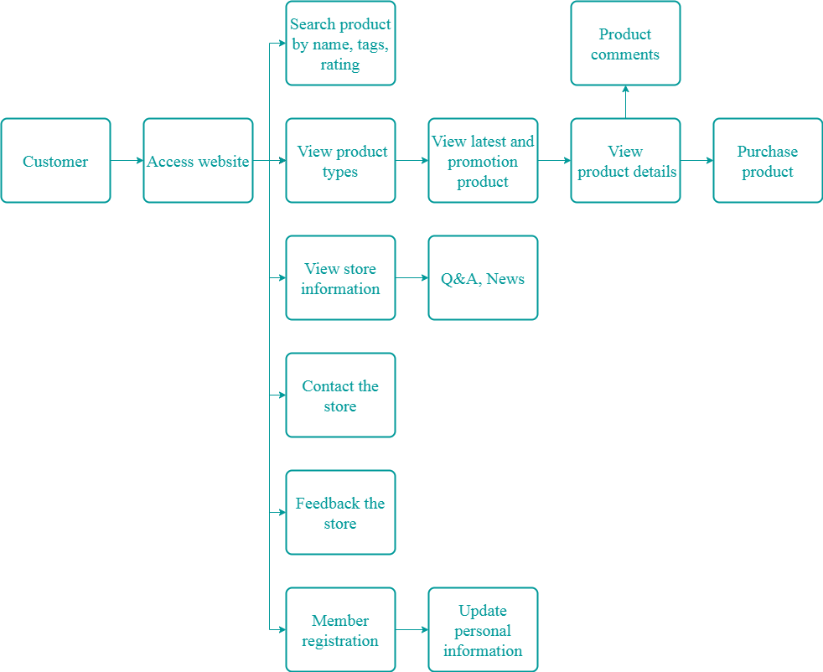

1. **Administrator**

|  |  |  |
| --- | --- | --- |
| **Input** | **Process** | **Output** |
| - Log-in.  - Perform create, update, and delete in the database.  - Check customer feedback.  - Check customer's product reviews.  Check customer's contact.  - Approve orders delivered to customers.  - View income. | - Check log-in.  - Create, Update, and Delete: Administration, Product, Comment, News, Q&A, Customer, Order.  - Get data from the database.  - Get information about new product comments from the database.  - Get contact’s data from the database.  - Get order information from the database, update and approve the delivered orders.  - Get information on orders from the database, and calculate the data. | - Display log-in result.  - Display new data after creating, updating, and deleting data.  - Display feedback.  - Display comment.  - Display contact.  - Display new orders.  - Display income.  - Display q&a, contacts from customer |

**Function Administrator** **Diagram**

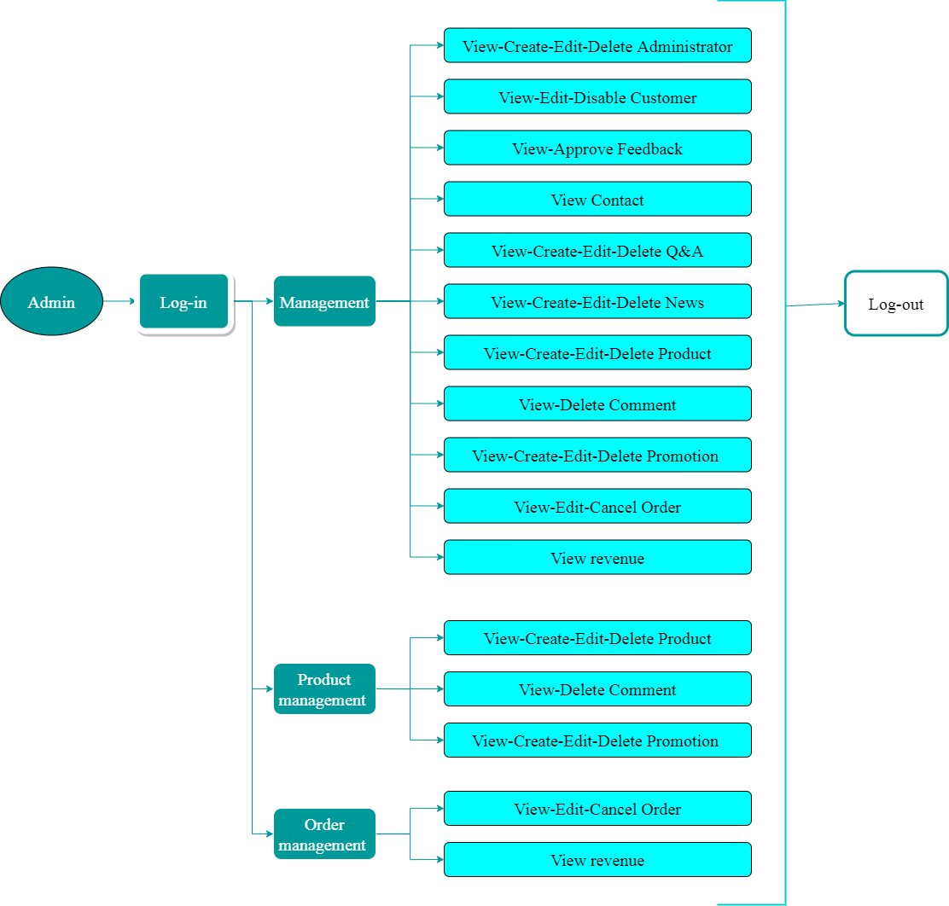

# SYSTEM REQUIREMENTS:

1. **Hardware requirements:**

* AMD Ryzen/ Intel core i3 3.0 GHz or higher
* RAM: 4 GB or better
* HDD: 2 GB or higher

1. **Software requirements:**

**Server-side:**

* Windows 7 x86/64 or higher (Recommended)
* Notepad/ HTML/ PHP editor such as Netbean, Dreamweaver CC, Notepad++.
* IE 11.0 or higher, Mozilla Firefox 50.0 or higher
* Wamp 3.3.0 or higher.

**Client-side:**

* Windows XP or higher (Recommended)
* IE 9.0 or higher
* Google Chrome latest

# SCOPE:

* Provide information about the products
* Let customers order products online
* No payment processing, only calculate bills

# Task Sheet Review 1

|  |  |  |  |  |  |
| --- | --- | --- | --- | --- | --- |
| **Members Group** | | **Date Preparation Of Activity Plan** | | | |
| **No** | **Name** | **Description Task** | **Start Date** | **End Date** | **Status** |
| 1 | Đào Bùi Quang Hưng | All member | 03/06/2022 | 08/06/2020 | Completed |
| 2 | Nguyễn Hoài Thương | All member | 03/06/2022 | 08/06/2020 | Completed |
| 3 | Nguyễn Ngọc Kim Ngân | All member | 03/06/2022 | 08/06/2020 | Completed |
| 4 | Lã Bảo Minh | All member | 03/06/2022 | 08/06/2020 | Completed |
|  | | | | | |
| **Teacher** | | | **Team Leader** | | |
|  | | |  | | |
| **Đào Ngọc Anh** | | | **Đào Bùi Quang Hưng** | | |

# REVIEW 2

# Project Design

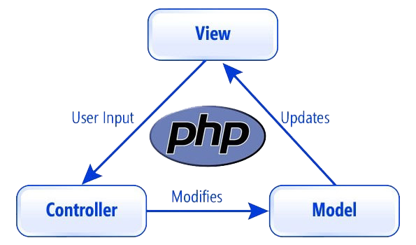

Designed according to the MVC model

# PROBLEM STATMENT:

**Definition:** A data-flow diagram is a way of representing a flow of data through a process or a system. The next step of systems analysis is a detailed review of the information required to implement the functions discussed above and the necessary methods to improve the operations. The most frequently used process model for this purpose is the DFD. DFD will support four main activities:

* **Analysis:** DFD is used to determine user requirements.
* **Design:** DFD plans and illustrates the solution for analysts and users while designing a new system.
* **Communication:** One of the DFD's strengths is its simplicity and ease of understanding for analysts and users.
* **Documentation:** The DFD describes the system requirements and design. DFD provides an overview of the system's main components but does not give details about them. We must use other tools such as database dictionaries and process specifications to understand the flow of information being exchanged and how to process that information.

**Elements of a context diagram:**

6

Process

**External entity:** a person, department, outside organization, or another information system that provides data or receives outputs from the system. They represent how the information system interacts with the outside world.

**Process:** A process receives input data and produces output with different content or form. An activity that changes or transforms data flows.

**Data Flow:** Movement of data between external entities, processes, and data stores is represented with an arrow, which indicates the flow direction.

**Data Store:** A data store does not generate operations but holds data for later access. Data stores could consist of long-term files or a batch of documents stored briefly while waiting to be processed. Input flows to a data store include information or operations that change the stored data. Output flows would be data retrieved from the store.

Data Flow

External Entity

Process

Data Store

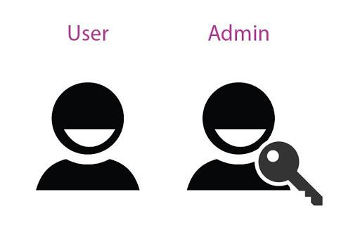

1 Data Store

## Otakool Map:

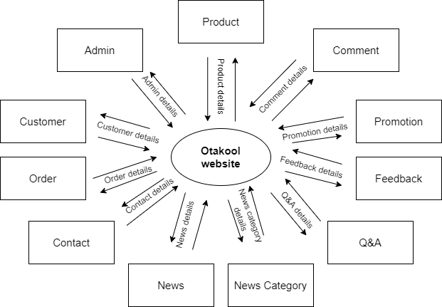

## Data Flow Diagram:

### Admin DFD:

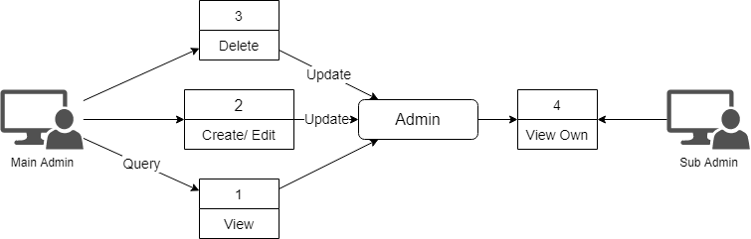

### Promotion DFD:

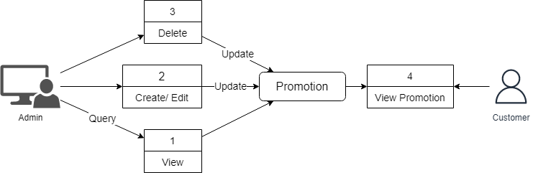

### Product DFD:

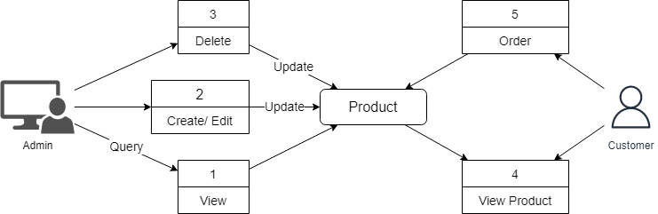

### Order DFD:

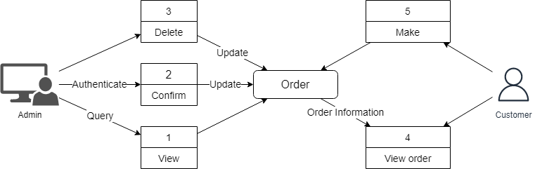

### Comment DFD:

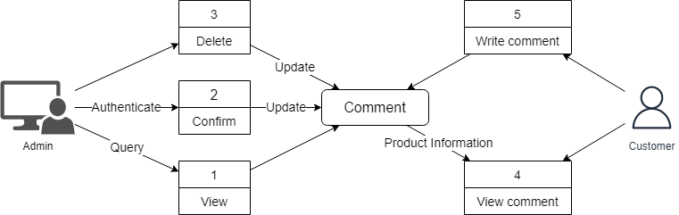

### Customer DFD:

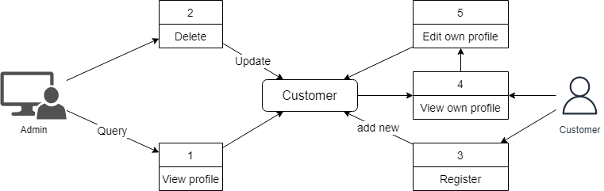

### Feedback DFD:

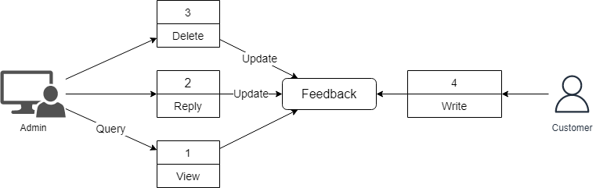

### News DFD:

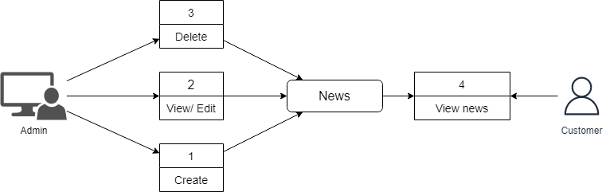

### News Category DFD:

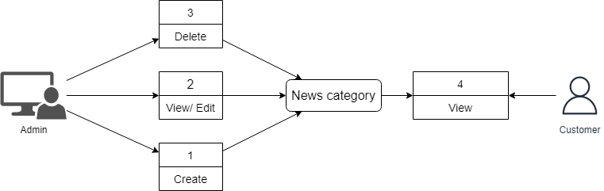

### Q&A (Question and Answer) DFD:

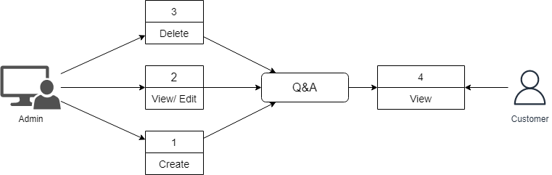

### Contact DFD:

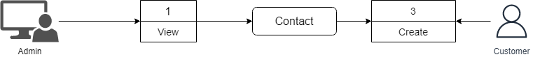

# DATABASE DESIGN:

## Entity Relation Diagram (ERD):

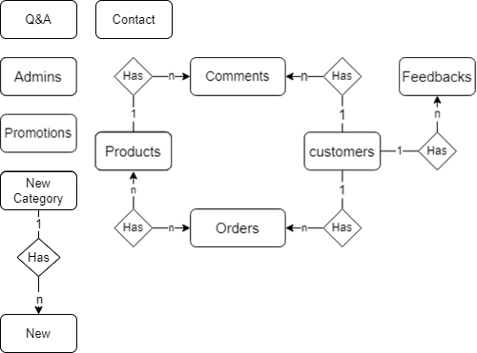

## Entity Description:

* **Promotions entity**

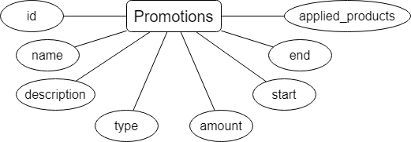

* **Products entity**

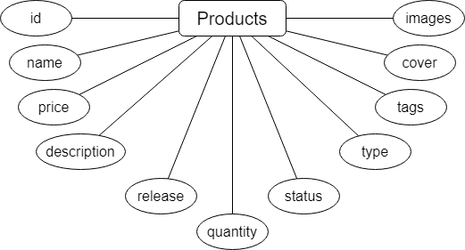

* **Comments entity**

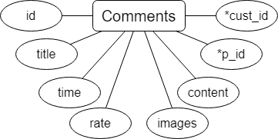

* **Orders entity**

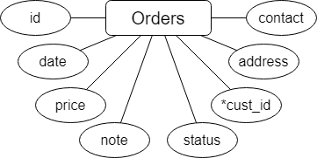

* **Order Details entity**

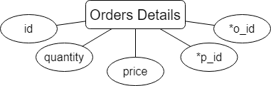

* **Customers entity**

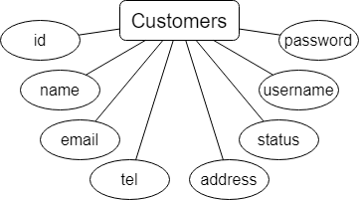

* **Feedbacks entity**

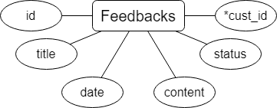

* **Admins entity**

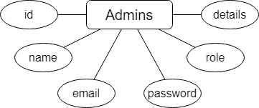

* **News entity**

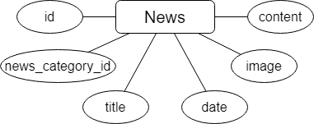

* **News category entity**

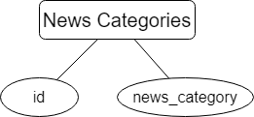

* **Q&A entity**

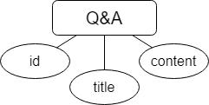

* **Contacts entity**

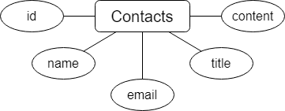

## Database Relation Diagram (DRD):

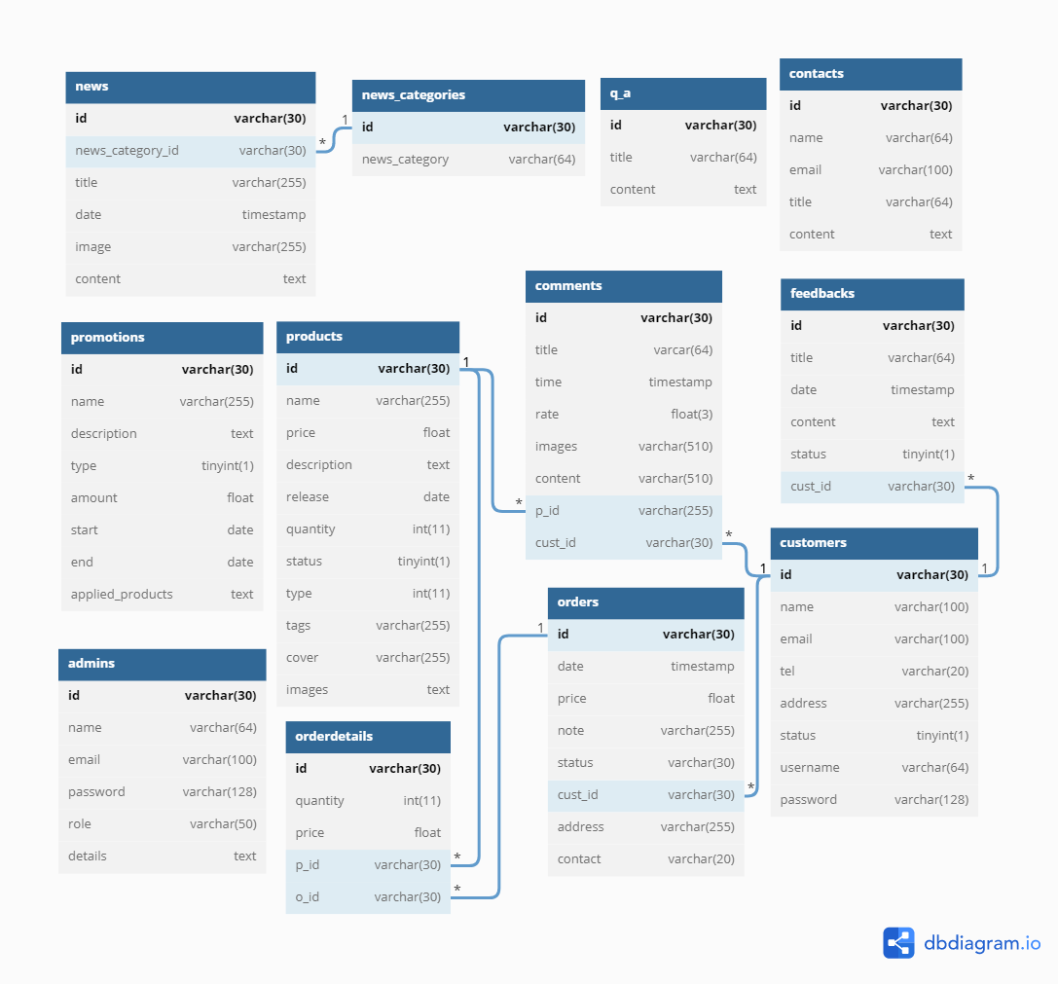

## Database Structure:

Foreign Key (FK)

|  |  |  |  |  |  |
| --- | --- | --- | --- | --- | --- |
| **promotions** | | | | | |
| **Name** | **Data Type** | **Primary Key** | **Not null** | **Description** |
| **id** | varchar(30) | X | X | Id of promotion |
| name | varchar(255) |  | X | Name of promotion |
| description | text |  |  | Description of promotion |
| type | tinyint(1) |  | X | Type of promotion (flat or %) reduction |
| amount | float |  | X | Amount reduce |
| start | date |  | X | Start date of promotion |
| end | date |  | X | End date of promotion |
| applied_products | text |  | X | Applied products’ id |

|  |  |  |  |  |  |
| --- | --- | --- | --- | --- | --- |
| **products** | | | | | |
| **Name** | **Data Type** | **Primary Key** | **Not null** | **Description** |
| **id** | varchar(30) | X | X | Id of product |
| name | varchar(255) |  | X | Name of product |
| price | float |  |  | Price of product |
| description | text |  |  | Description of product |
| release | date |  |  | Released date of product |
| quantity | int(11) |  | X | Quantity of product |
| status | tinyint(1) |  | X | Status of product (Available/Not) |
| type | int(11) |  | X | Type of product |
| tags | varchar(255) |  |  | Product tags |
| cover | varchar(255) |  |  | Product’s cover image |
| images | text |  |  | Product‘s other images |

|  |  |  |  |  |  |
| --- | --- | --- | --- | --- | --- |
| **comments** | | | | | |
| **Name** | **Data Type** | **Primary Key** | **Not null** | **Description** |
| **id** | varchar(30) | X | X | Id of comment |
| title | varchar(64) |  | X | Title of comment |
| time | timestamp |  | X | Timestamp of comment |
| rate | float(3) |  | X | Product rating |
| images | varchar(510) |  |  | Product images |
| content | varchar(510) |  |  | Comment’s content |
| **p_id** | varchar(30) |  | X | FK ref **products** table |
| **cust_id** | varchar(30) |  | X | FK ref **customers** table |

|  |  |  |  |  |  |
| --- | --- | --- | --- | --- | --- |
| **orders** | | | | | |
| **Name** | **Data Type** | **Primary Key** | **Not null** | **Description** |
| **id** | varchar(30) | X | X | Id of order |
| date | timestamp |  | X | Timestamp of order |
| price | float |  | X | Price of order |
| note | varchar(255) |  |  | Note for delivery |
| status | varchar(30) |  | X | Status of order (cart/ pending/ processing/ delivered) |
| **cust_id** | varchar(30) |  | X | FK ref **customers** table |
| address | varchar(255) |  | X | Delivery address |
| contact | varchar(20) |  | X | Contact number |

|  |  |  |  |  |  |
| --- | --- | --- | --- | --- | --- |
| **orderdetails** | | | | | |
| **Name** | **Data Type** | **Primary Key** | **Not null** | **Description** |
| **id** | varchar(30) | X | X | Id of order detail |
| quantity | int(11) |  | X | Quantity of product |
| price | float |  | X | Price of product (after promotion) |
| **p_id** | varchar(30) |  | X | FK ref **products** table |
| **o_id** | varchar(30) |  | X | FK ref **orders** table |

|  |  |  |  |  |  |
| --- | --- | --- | --- | --- | --- |
| **customers** | | | | | |
| **Name** | **Data Type** | **Primary Key** | **Not null** | **Description** |
| **id** | varchar(30) | X | X | Id of customer |
| name | varchar(100) |  | X | Name of customer |
| email | varchar(100) |  | X | Email of customer |
| tel | varchar(20) |  | X | Phone number |
| address | varchar(255) |  | X | Customer address |
| status | tinyint(1) |  | X | Status of customer |
| username | varchar(64) |  | X | Username of account |
| password | varchar(128) |  | X | Password of account |

|  |  |  |  |  |  |
| --- | --- | --- | --- | --- | --- |
| **feedbacks** | | | | | |
| **Name** | **Data Type** | **Primary Key** | **Not null** | **Description** |
| **id** | varchar(30) | X | X | Id of feedback |
| title | varchar(64) |  | X | Title of feedback |
| date | timestamp |  | X | Feedback date |
| content | text |  | X | Feedback content |
| status | tinyint(1) |  | X | Status of feedback (answered/pending) |
| **cust_id** | varchar(30) |  | X | FK ref **customers** table |

|  |  |  |  |  |  |
| --- | --- | --- | --- | --- | --- |
| **admins** | | | | | |
| **Name** | **Data Type** | **Primary Key** | **Not null** | **Description** |
| **id** | varchar(30) | X | X | Id of admin |
| name | varchar(64) |  | X | Name of admin |
| email | varchar(100) |  | X | Email address |
| password | varchar(128) |  | X | Password |
| role | varchar(50) |  | X | Admin role (main/ product/ order) |
| details | text |  |  | Details of admin |

|  |  |  |  |  |  |
| --- | --- | --- | --- | --- | --- |
| **news** | | | | | |
| **Name** | **Data Type** | **Primary Key** | **Not null** | **Description** |
| **id** | varchar(30) | X | X | Id of news |
| title | varchar(255) |  | X | Title of news |
| date | timestamp |  | X | Date published |
| image | varchar(255) |  | X | Image of news |
| content | text |  | X | Content of news |
| news_category_id | varchar(30) |  | X | FK ref **news_categories** table |

|  |  |  |  |  |  |
| --- | --- | --- | --- | --- | --- |
| **news_categories** | | | | | |
| **Name** | **Data Type** | **Primary Key** | **Not null** | **Description** |
| **id** | varchar(30) | X | X | Id of news category |
| news_category | varchar(64) |  | X | Category of news |

|  |  |  |  |  |  |
| --- | --- | --- | --- | --- | --- |
| **q_a** | | | | | |
| **Name** | **Data Type** | **Primary Key** | **Not null** | **Description** |
| **id** | varchar(30) | X | X | Id of q&a |
| title | varchar(64) |  | X | Question |
| content | text |  | X | Answer |

|  |  |  |  |  |  |
| --- | --- | --- | --- | --- | --- |
| **contacts** | | | | | |
| **Name** | **Data Type** | **Primary Key** | **Not null** | **Description** |
| **id** | varchar(30) | X | X | Id of contacts |
| name | varchar(64) |  | X | Name of guest/customer |
| email | varchar(100) |  | X | Email of guest/customer |
| title | varchar(64) |  | X | Title of contact |
| content | text |  | X | Content of contact |

# SITEMAP:

## Customer sitemap

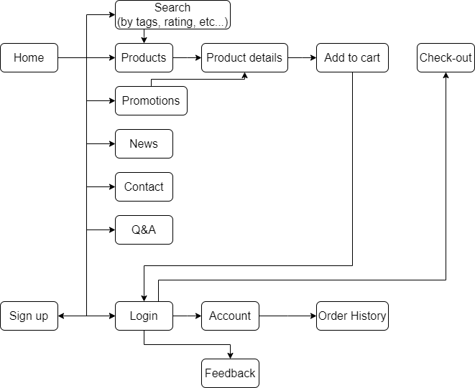

## Admin sitemap

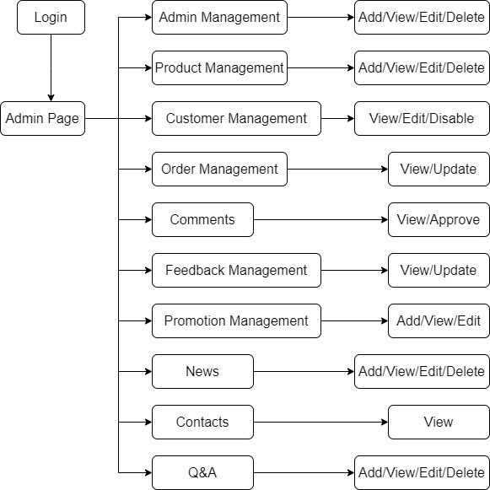

# Task Sheet Review 2

|  |  |  |  |  |  |
| --- | --- | --- | --- | --- | --- |
| **Members Group** | | **Date Preparation Of Activity Plan** | | | |
| **No** | **Name** | **Description Task** | **Start Date** | **End Date** | **Status** |
| 1 | Đào Bùi Quang Hưng | All | 08/06/2022 | 15/06/2020 | Completed |
| 2 | Nguyễn Hoài Thương | All | 08/06/2022 | 15/06/2020 | Completed |
| 3 | Nguyễn Ngọc Kim Ngân | All | 08/06/2022 | 15/06/2020 | Completed |
| 4 | Lã Bảo Minh | All | 08/06/2022 | 15/06/2020 | Completed |
|  | | | | | |
| **Teacher** | | | **Team Leader** | | |
|  | | |  | | |
| **Đào Ngọc Anh** | | | **Đào Bùi Quang Hưng** | | |

# REVIEW 3

# A – Customer Pages

## Header:



* **Purpose:** Show site logo, links to main pages, search for products (general).
* **To:** Link to other pages.
* **Description:** Always at the top of the website, cart take information from the following table: order. Profile take information from table: customer.

## Footer:



* **Purpose:** Link to main product pages, show shop contact information.
* **To:** Link to other pages.
* **Description:** Always at the bottom of the website.

## Home page:

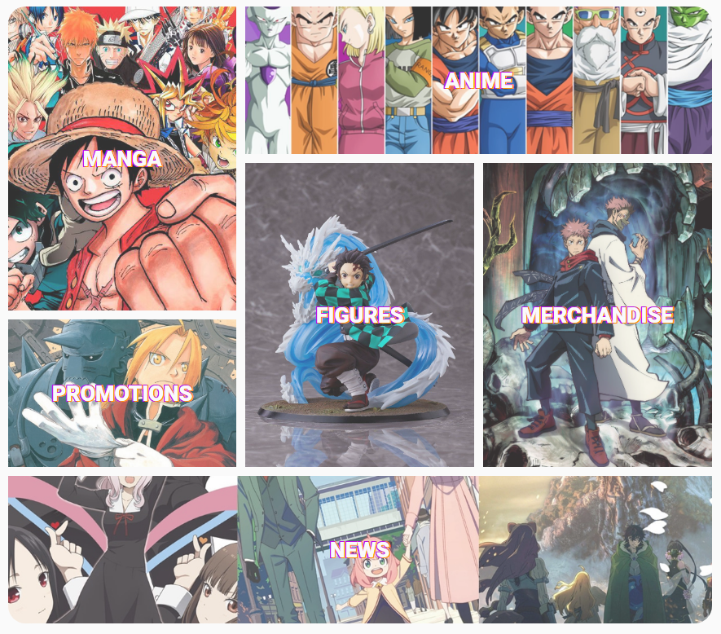

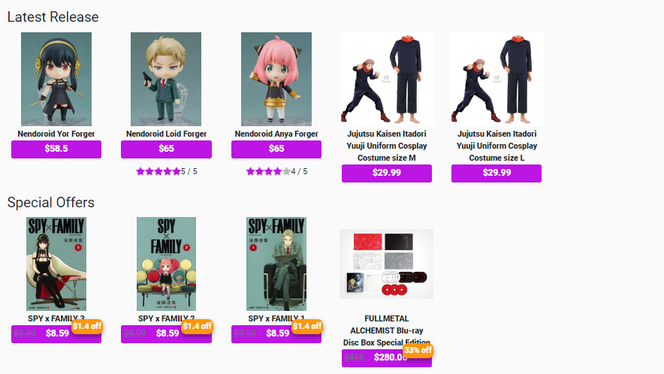

* **Purpose:** Show links to see the list of products, several of the latest available products and special offers.
* **From:** Header link (Logo), Footer link.
* **To:** Link to other pages.
* **Description:** Customers choose a product category to view a list of related products. Customers who choose to create an account will go to the member registration page or choose to login to go to the member login page. All links in the header and footer lead to another page. This home page take information from the products table.

## Register page:

* **Purpose:** Customers register for an account.
* **From:** Create account link on top-right.
* **To:** Click “Create” redirects to Login page.
* **Description:** This page takes information and saves it to the customers table. Customers create an account to log in and store personal information.

|  |  |  |
| --- | --- | --- |
| **Form** | **Type** | **Validation** |
| Name | Text | Not blank, only letters and spaces, between 3 and 100 characters. |
| Username | Text | Not blank, unique, only letters, digits and underscore, between 3 and 64 characters. |
| Email | Email | Not blank, unique, check email according to xxx@xxx.xxx or xxx.@xxx.xxx.xx . |
| Phone number | Number | Not blank, non-negative numbers, only 10 digits, starting from 03, 05, 07, 08 or 09. |
| Address | Text | Not blank. |
| Password | Password | Not blank, at least 8 characters, contain at least 1 number and at least 1 letter. |
| Confirm Password | Password | Not blank, must be the same password, at least 8 characters, contain at least 1 number and at least 1 letter. |

## Login page:

* **Purpose:** Customers login to buy products and view account information.
* **From:** Top right link in header if not logged in yet
* **To:** Home page logged in
* **Description:** This page retrieves information that matches the customers table. The customer will be allowed to login if the email and password are correct. If it is incorrect, then log in again.

|  |  |  |
| --- | --- | --- |
| **Form** | **Type** | **Validation** |
| Email | Email | Not blank, check email according to xxx@xxx.xxx or xxx.@xxx.xxx.xx . |
| Password | Password | Not blank, at least 8 characters, contain at least 1 number and at least 1 letter. |

## My Profile:

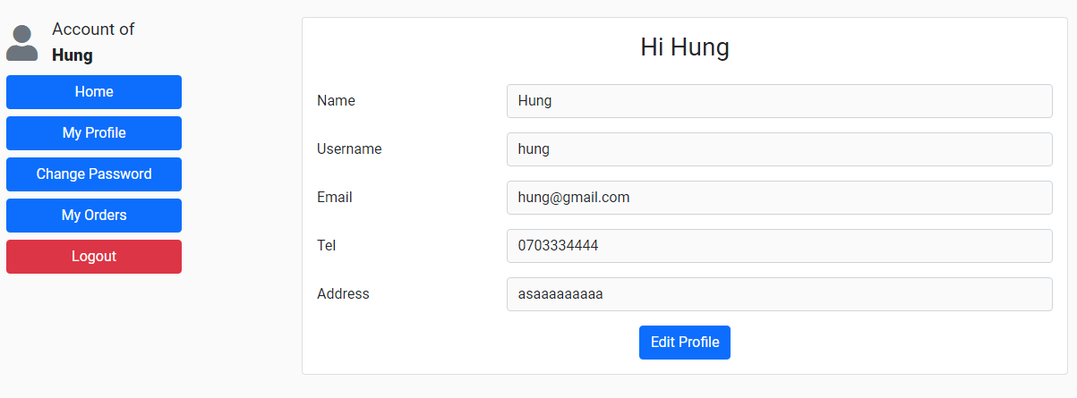

* **Purpose:** Customers view account information.
* **From:** Top right link in the header.
* **To:** Click “Edit Profile” button redirects to edit customer profile page.
* **Description:** Customers view details information. These pages take information from the following tables: customers.

## Edit My Profile:

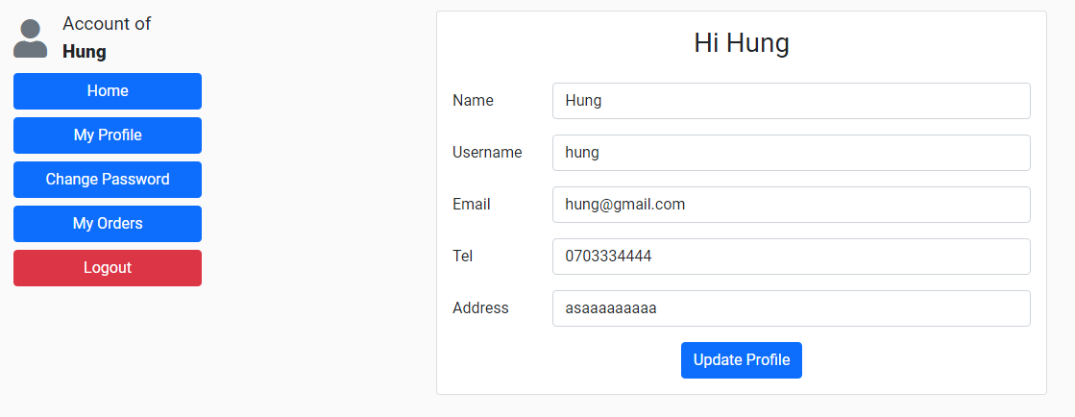

* **Purpose:** Customers edit account information.
* **From:** Edit Profile page.
* **To:** Click “Save Changes” button redirects to My Profile page.
* **Description:** Customers can change their information and data update in the customers table. These pages take information from the following tables: customers.

|  |  |  |
| --- | --- | --- |
| **Form** | **Type** | **Validation** |
| Name | Text | Not blank, only letters and spaces, between 3 and 100 characters. |
| Username | Text | Not blank, unique, only letters, digits and underscore, between 3 and 64 characters. |
| Email | Email | Not blank, unique, check email according to xxx@xxx.xxx or xxx.@xxx.xxx.xx . |
| Phone number | Number | Not blank, non-negative numbers, only 10 digits, starting from 03, 05, 07, 08 or 09. |
| Address | Text | Not blank. |

## My orders:

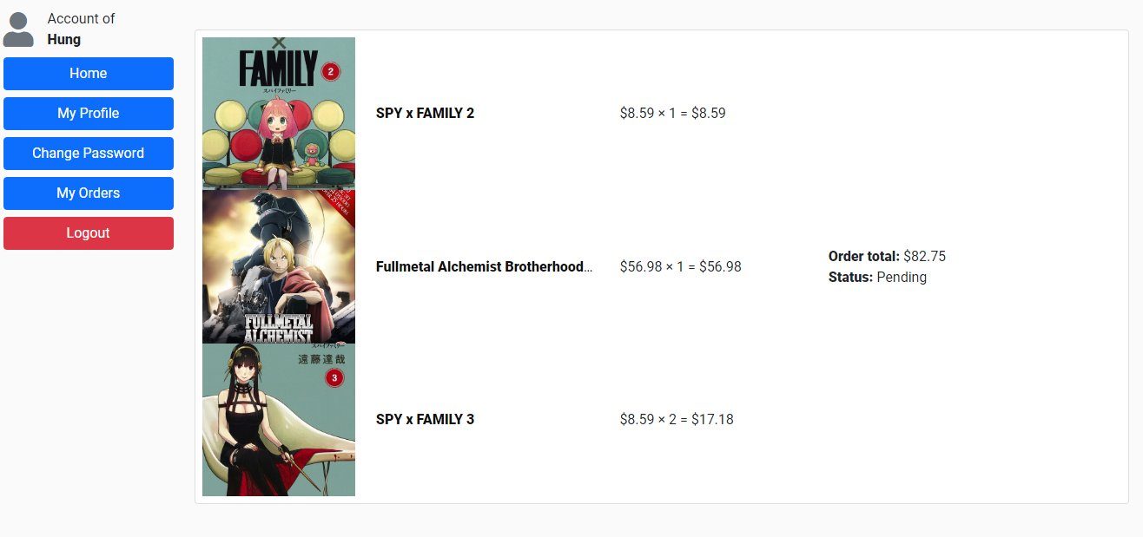

* **Purpose:** Customers view details of their orders.
* **From:** My Orders.
* **Description:** Customers view details of their orders. This page take information from the following tables: order, order details.

## Change customer password:

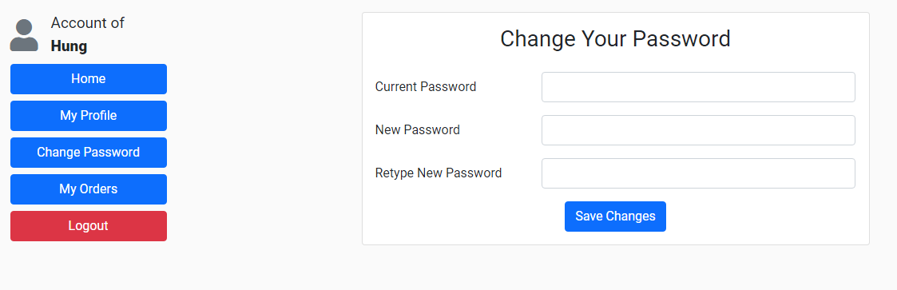

* **Purpose:** Customers change password for their account.
* **From:** My Profile.
* **To:** Click “Save Changes” redirects to the same page.
* **Description:** Customers can change their password and data update in the customers table. This page take information from the following tables: customers.

|  |  |  |
| --- | --- | --- |
| **Form** | **Type** | **Validation** |
| Current Password | Password | Not blank, must be the same current password. |
| New Password | Password | Not blank, at least 8 characters, contain at least 1 number and at least 1 letter. |
| Retype New Password | Password | Not blank, must be the same new password, at least 8 characters, contain at least 1 number and at least 1 letter. |

## Product pages (Manga/Anime/Figure/Merchandise):

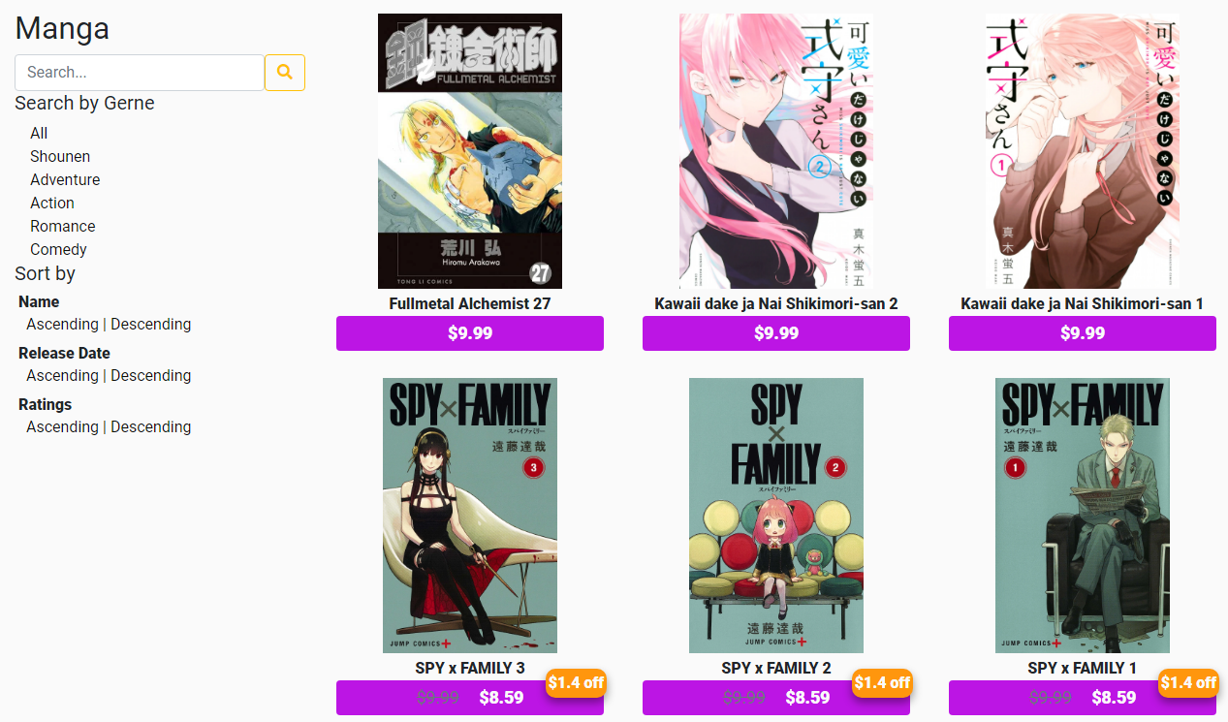

* **Purpose:** Show list of products according to type, customer can search for product by specific categories, by rating, by release date, or search by name through the search bar on the left panel.
* **From:** Links in the header (manga/ anime/ figure/ merchandise)
* **To:** Product details
* **Description:** These pages take information from the following tables: products, comments (for rating), and promotions

## Promotions:

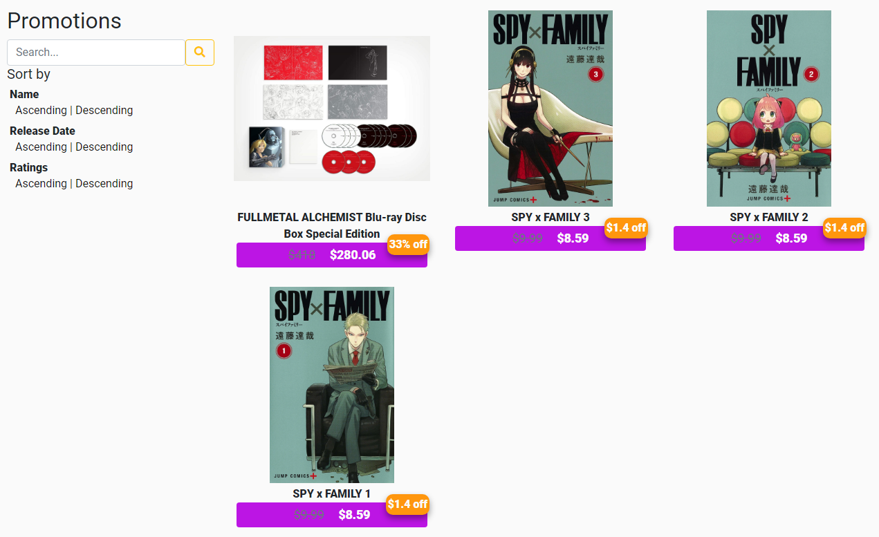

* **Purpose:** Show list of items that have promotions
* **From:** Links in the header (promotion)
* **To:** Order details
* **Description:** These pages take information from the following tables: products, promotions

## Search:

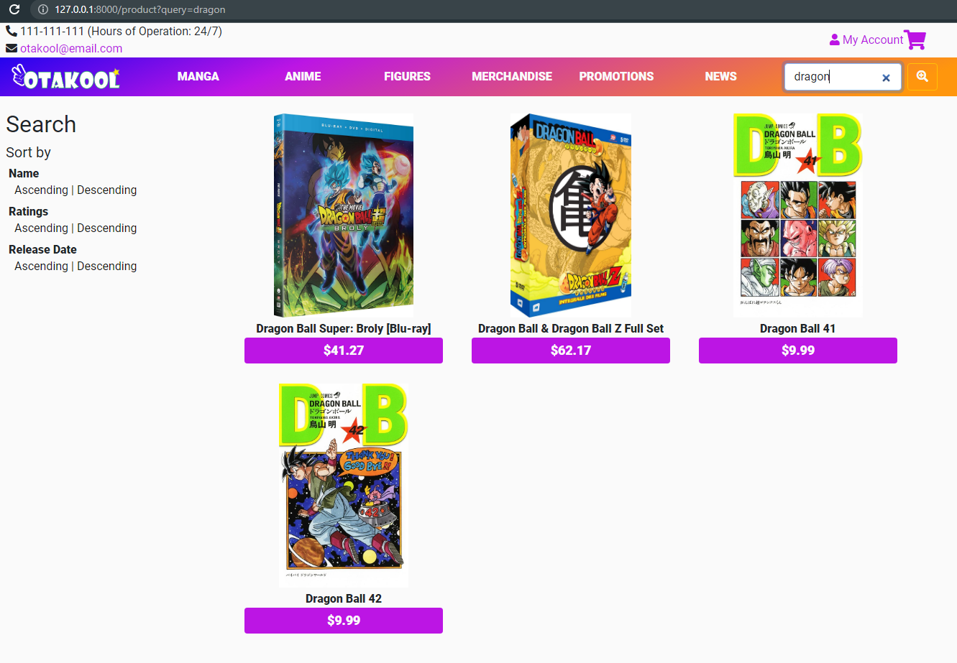

* **Purpose:** Search for products
* **From:** search bar in the header (products)
* **To:** Order details
* **Description:** These pages take information from the following tables: products, promotions

## Product details:

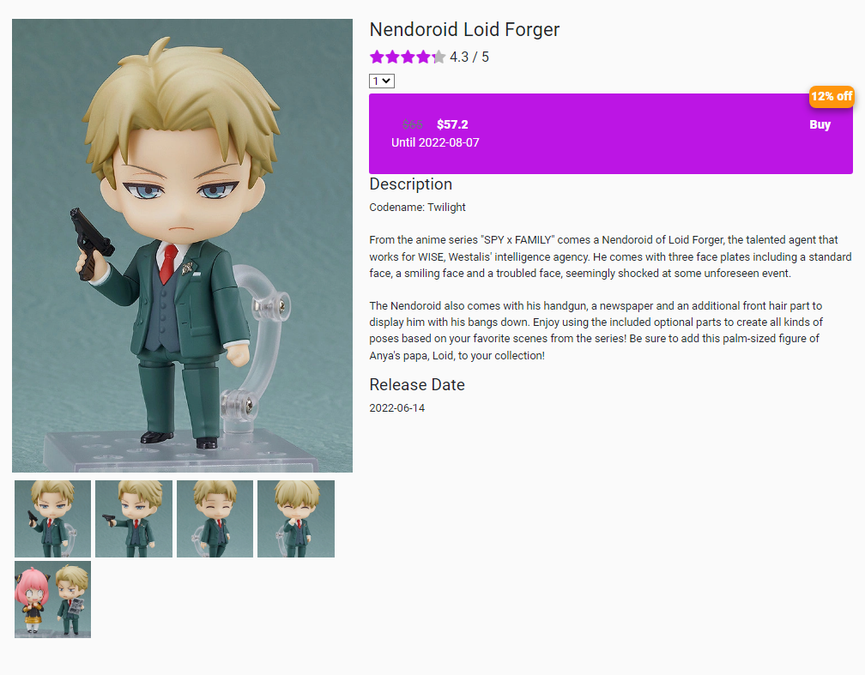

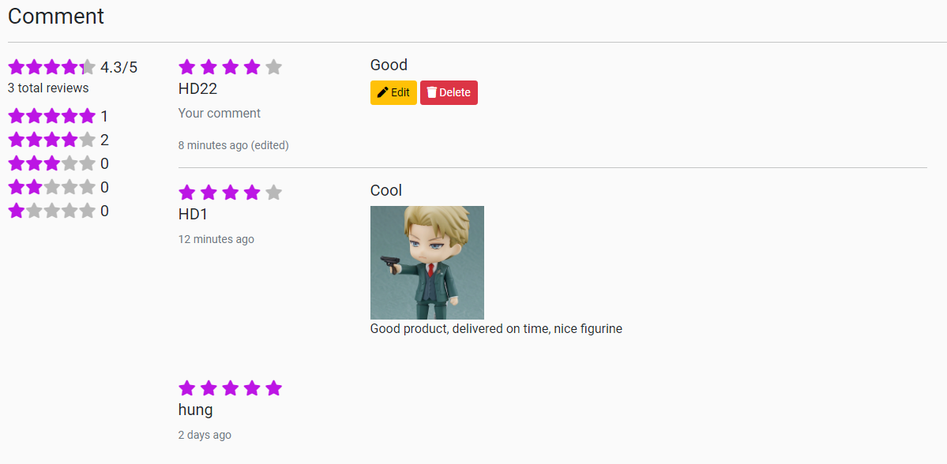

* **Purpose:** Show product’s details, allow customers to make and view comments, promotion price (if any), rate product, add products to cart
* **From:** Product list, Promotion list
* **To:** Order (cart) after clicking on “Buy” button
* **Description:** These pages take information from the following tables: products, comments, customers, promotions

|  |  |  |
| --- | --- | --- |
| **Form (comment)** | **Type** | **Validation** |
| Rate | radio | 1-5 star |
| Title | text | Null |
| images | file images | Null |
| Content | Textarea | Null |

## Shopping Cart:

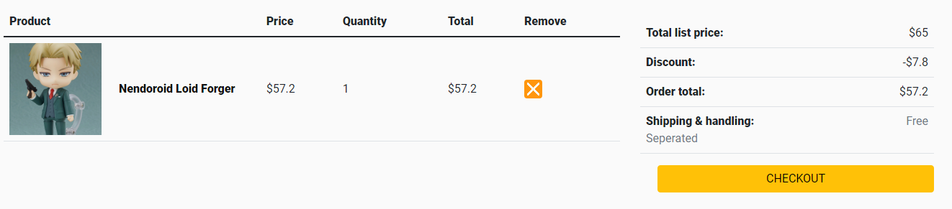

* **Purpose:** Show customer’s current cart
* **Description:** These pages take information from the following tables: order, orderdetails

## Check out page:

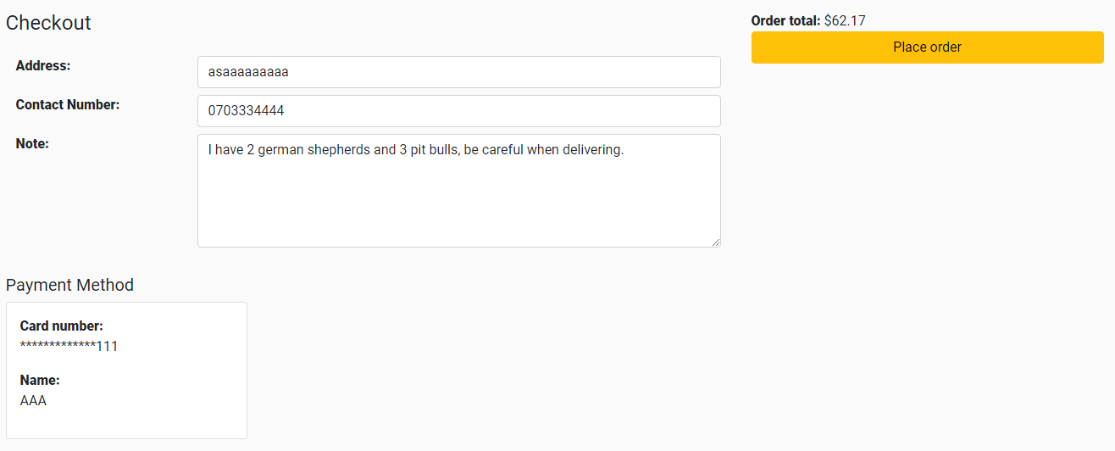

* **Purpose:** Check out page, allow customer to edit delivery address, contact number, and include any note for delivering.
* **Description:** These pages take information from the following tables: orderdetails

## Feedback:

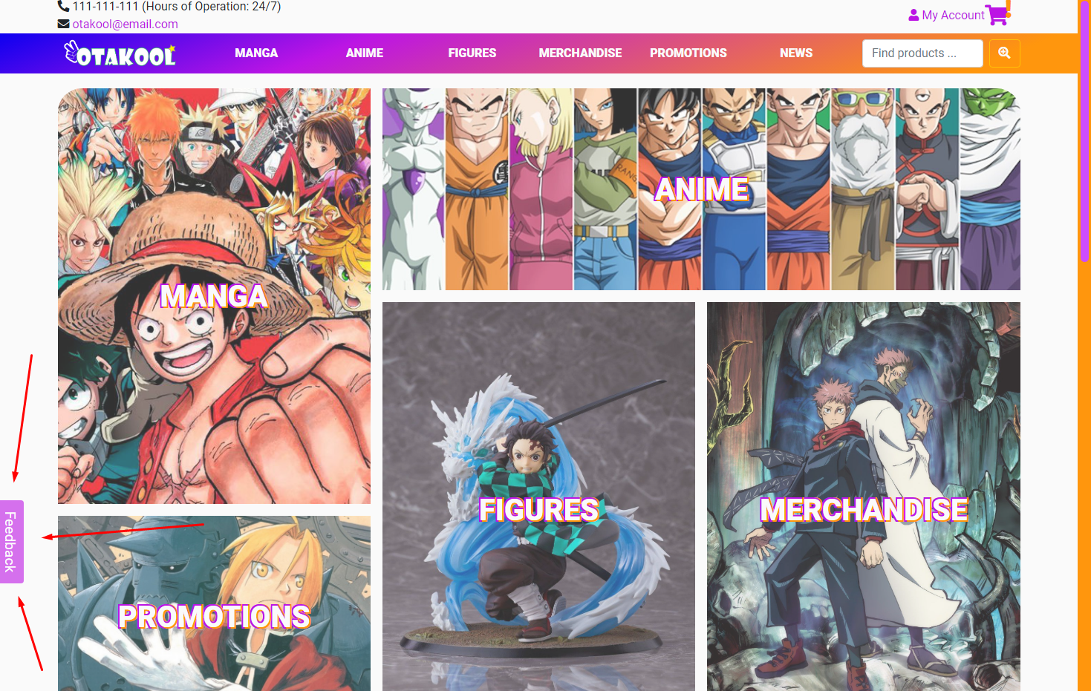

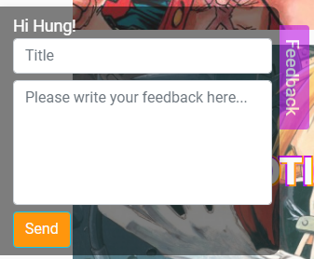

* **Purpose:** Send feedback (for customers)
* **Location:** Always at the bottom corner of the website as a fixed button (shown only for logged in customers)
* **Description:** Press button to pop up, customer can open up to type in feedback

## News page:

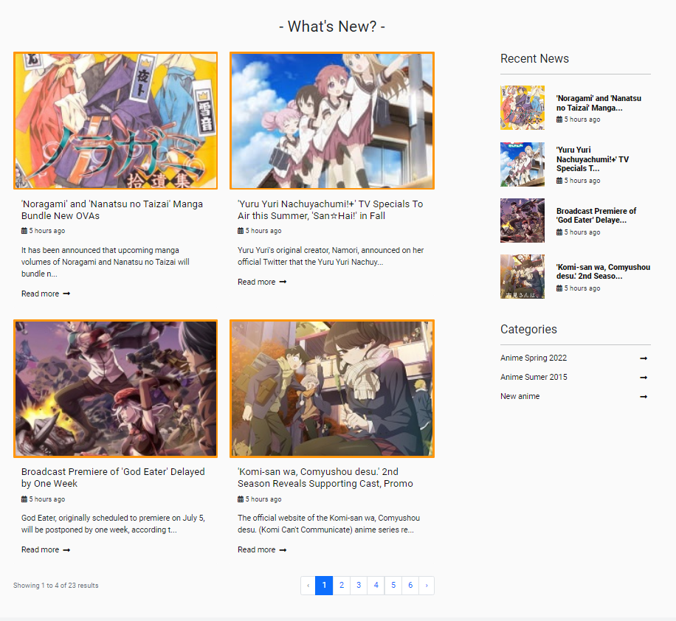

* **Purpose:** Show news list
* **From:** nav-bar link
* **Description:** These pages take information from the following tables: news, news_category

## News details:

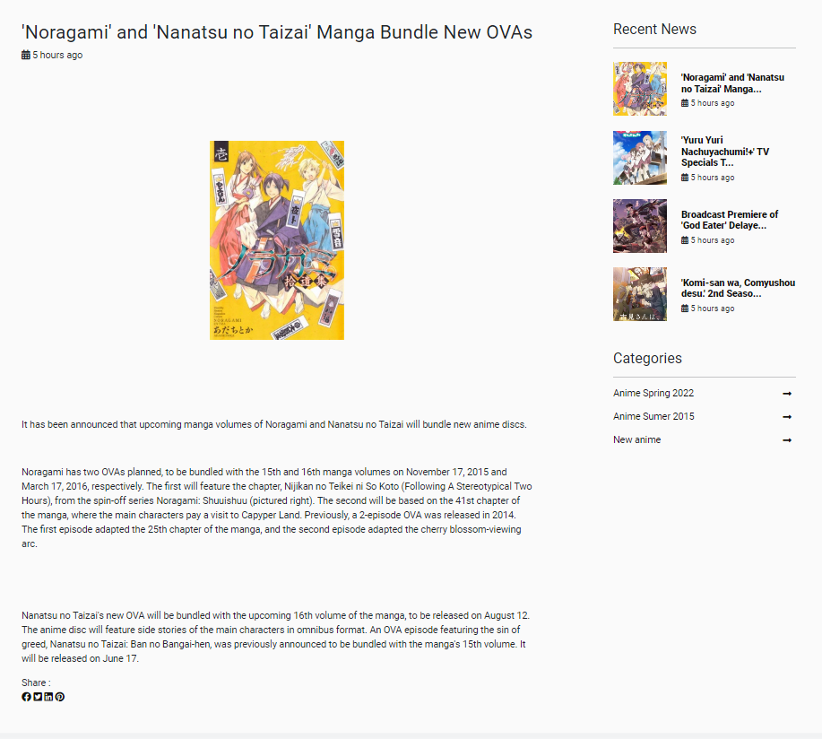

* **Purpose:** Show news details
* **From:** news list
* **Description:** These pages take information from the following tables: news, news_category

## Contact page:

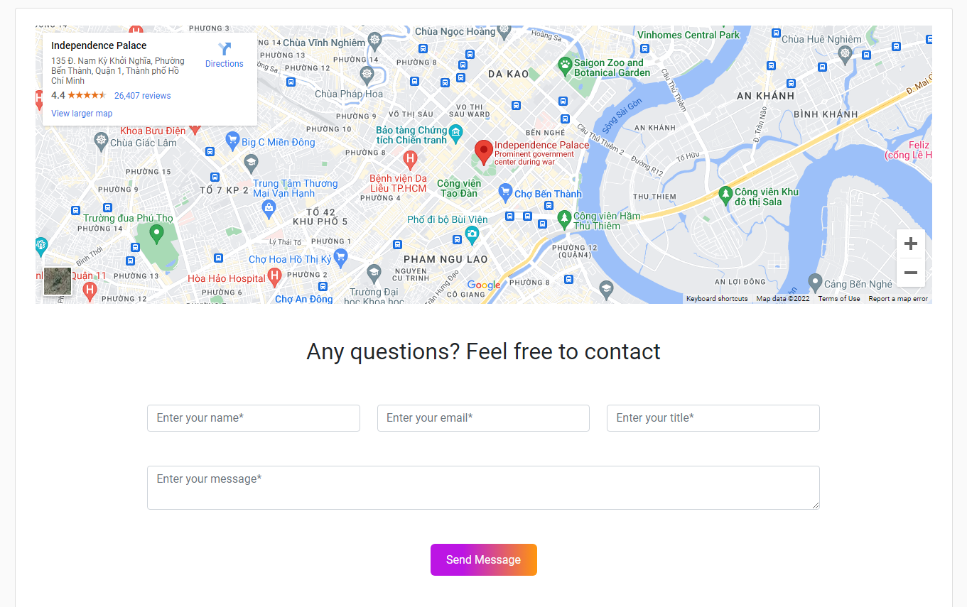

* **Purpose:** Show shop contact information, address. Customers and guesses can contact the store for more information.
* **From:** Footer link
* **Description:** Has map

|  |  |  |
| --- | --- | --- |
| **Form** | **Type** | **Validation** |
| Name | Text | Not blank, only letters and spaces, between 3 and 64 characters. |
| Email | Email | Not blank, check email according to xxx@xxx.xxx or xxx.@xxx.xxx.xx . |
| Title | Text | Not blank. |
| Message | Textarea | Not blank. |

## Q&A page:

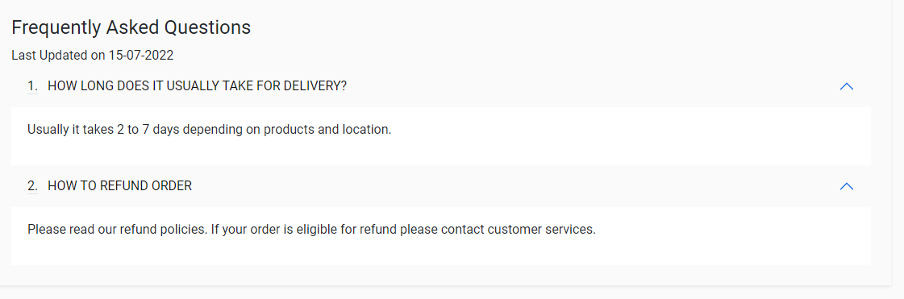

* **Purpose:** Show frequently asked questions
* **From:** Footer link
* **Description:** These pages take information from the following tables: q_a

# B – Admin Pages

## Login:

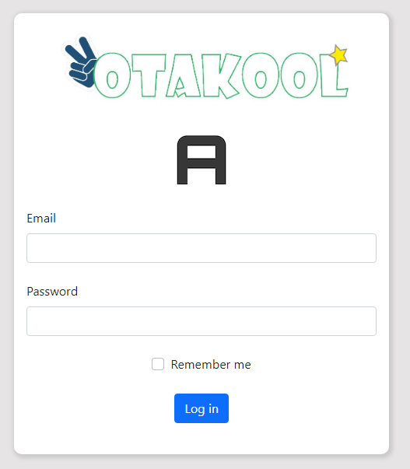

* **Purpose:** Admin log in.
* **From:** admin login by the link <http://www.otakool.com/admin/login>
* **To:** Back end index
* **Description:** This page retrieves information that matches the admins table. The admin will be allowed to log in if the email and password are correct. If it is incorrect, then log in again.

|  |  |  |
| --- | --- | --- |
| **Form** | **Type** | **Validation** |
| Email | Email | Not blank, check email according to xxx@xxx.xxx or xxx.@xxx.xxx.xx . |
| Password | Password | Not blank, at least 8 characters, contain at least 1 number and at least 1 letter. |

## Back end index:

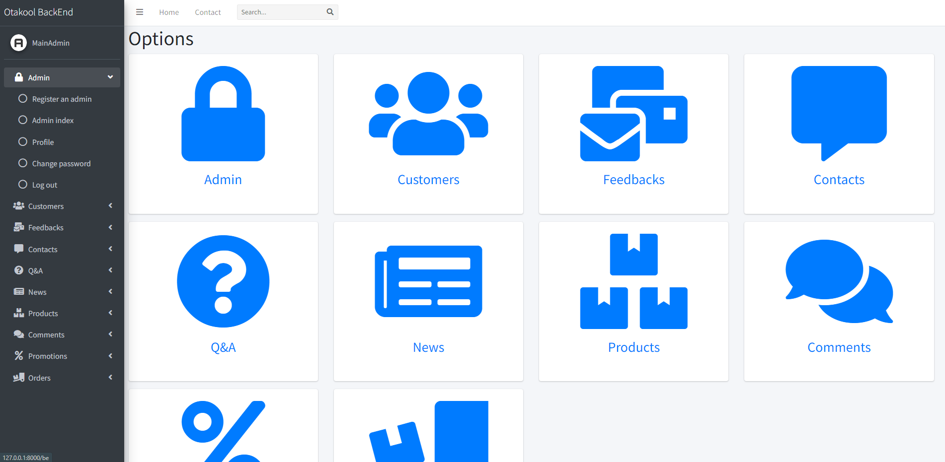

(Main Admin view)

* **Purpose:** Show current admin access depending on role
* **From:** Login admin page
* **Description:** Link to other pages

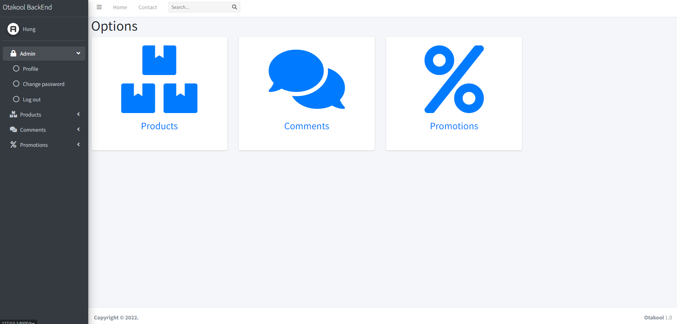

(Product Management Admin view)

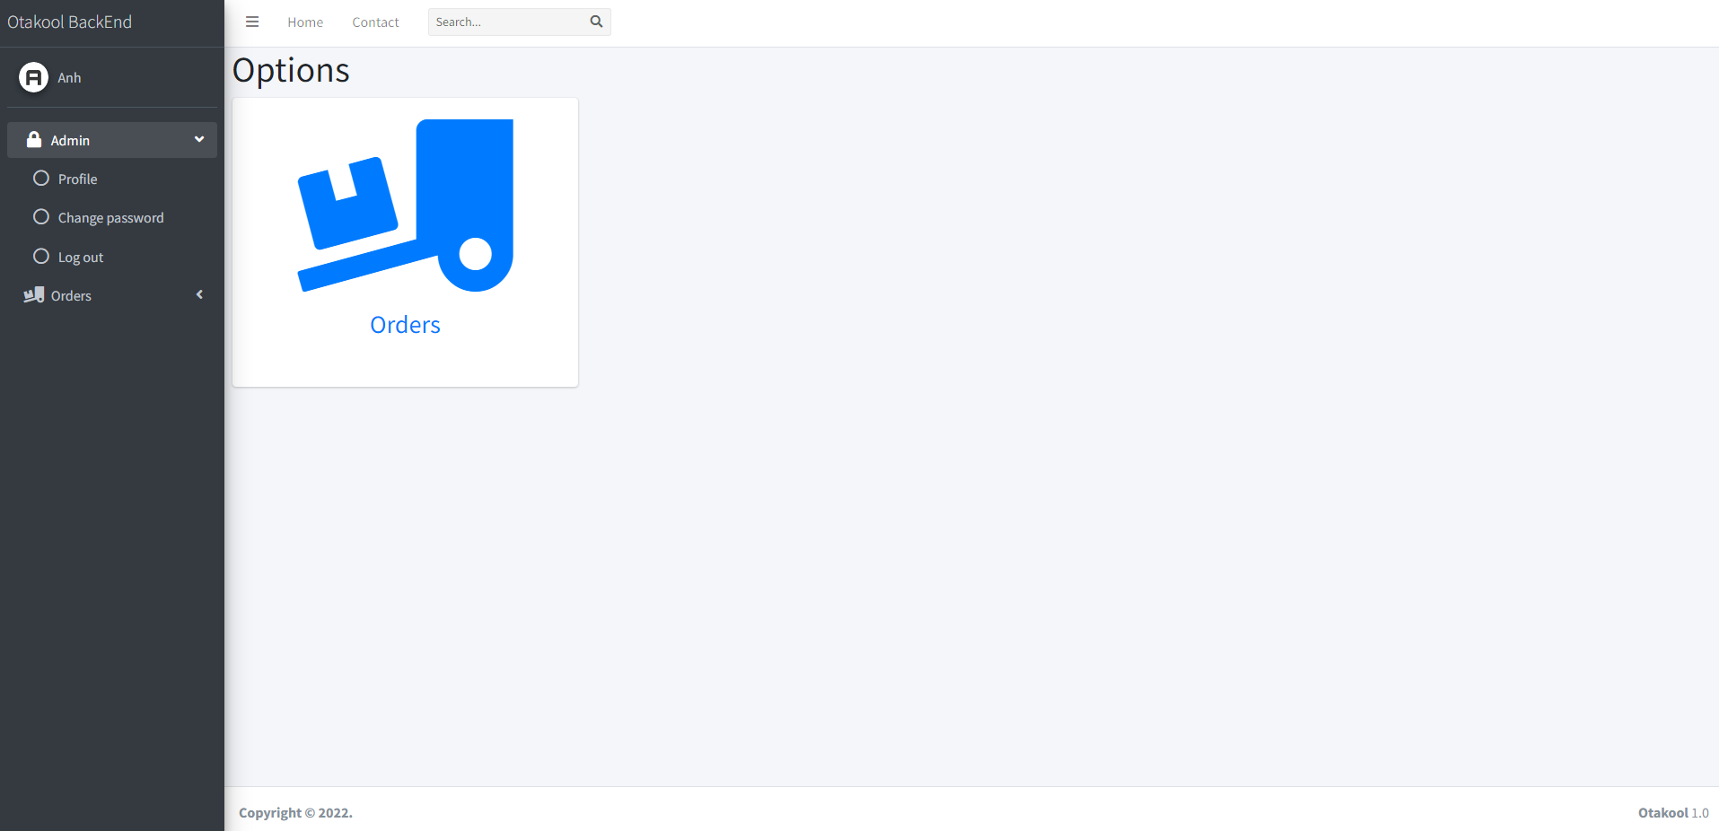

(Order Management Admin view)

## Admin management:

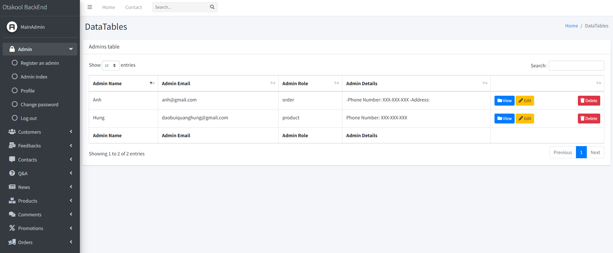

* **Purpose:** Main admin view list of other admin accounts and edit, delete other admins.
* **From:** Introduce admin to list of admins, side bar, index
* **To:** All links from the sidebar link to other pages. The “View” button redirects to Profile page. The "Edit" button redirects to the edit admin profile page. “Register an admin” from the sidebar redirects to register an admin page. “Profile” from sidebar redirects to profile page. “Change password” from sidebar redirects to change password page. “Logout” from sidebar redirects to log in admin page.
* **Description:** These pages take information from the following tables: admins.

## Register an admin:

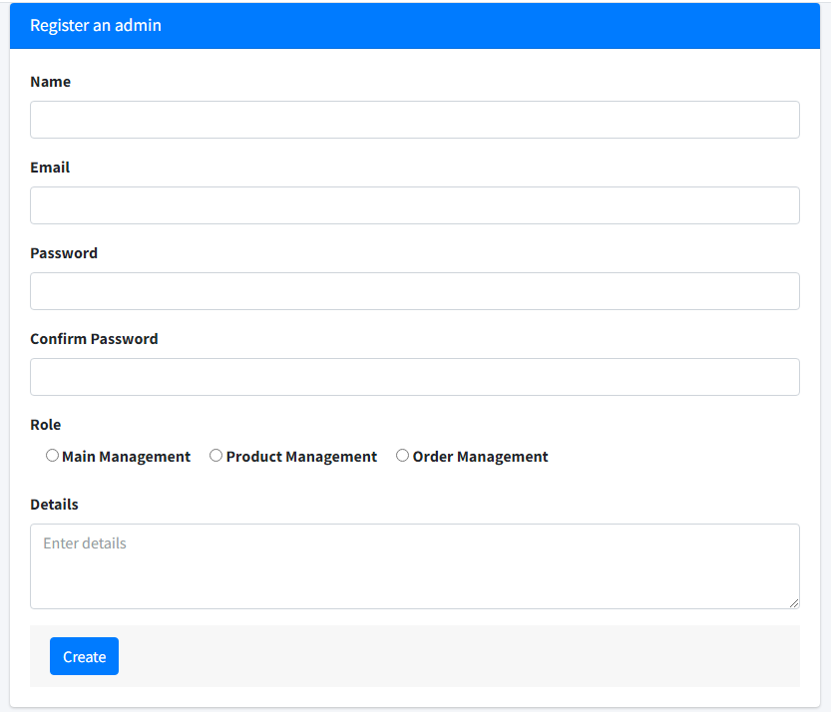

* **Purpose:** Only the main admin can register accounts for other admins.
* **From:** Admin management click “Register an admin” from sidebar.
* **To:** Click “Create” redirect to Admin management page.
* **Description:** This page saves information to the admins table. Main admin creates an account for other admins to log in and store their personal information.

|  |  |  |
| --- | --- | --- |
| **Form** | **Type** | **Validation** |
| Name | Text | Not blank, unique, only letters and spaces, between 3 and 64 characters. |
| Email | Email | Not blank, unique, check email according to xxx@xxx.xxx or xxx.@xxx.xxx.xx . |
| Password | Password | Not blank, at least 8 characters, contain at least 1 number and at least 1 letter. |
| Confirm Password | Password | Not blank, must be the same password, at least 8 characters, contain at least 1 number and at least 1 letter. |
| Role | Radio button | Not blank. |
| Details | Textarea | Null |

## Admin profile:

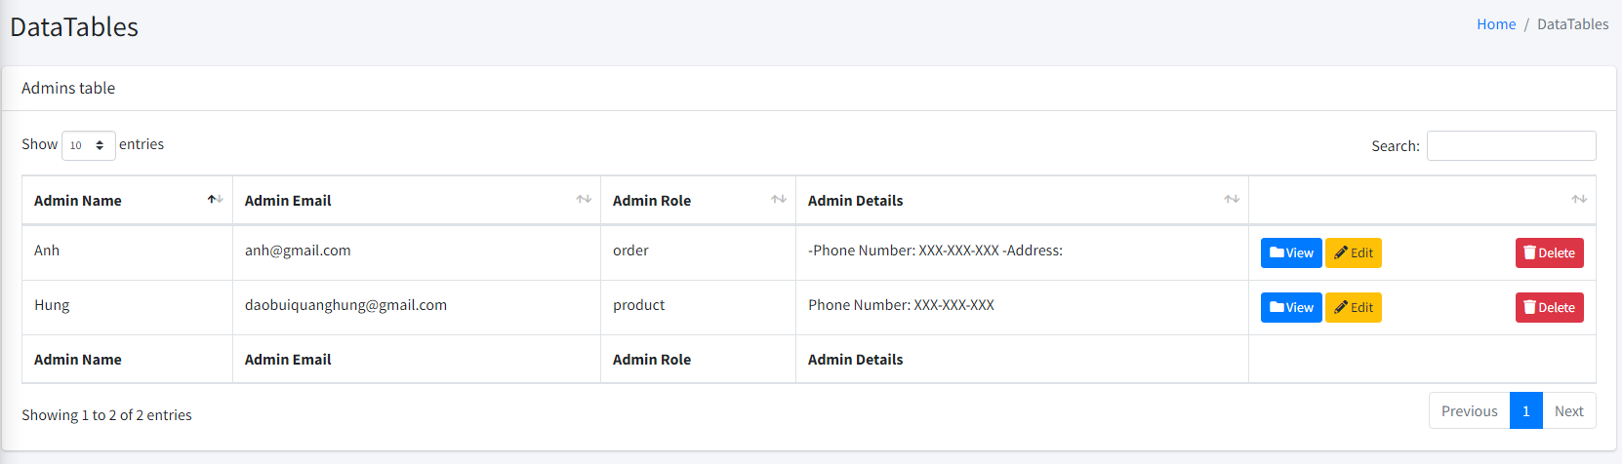

* **Purpose:** Admins view their information. (main admin only)
* **From:** Admin to Profile.
* **To:** Click "Edit Profile" button redirects to the edit admin profile page. All links from the sidebar link to other pages.
* **Description:** These pages take information from the following tables: admins.

## Edit admin profile:

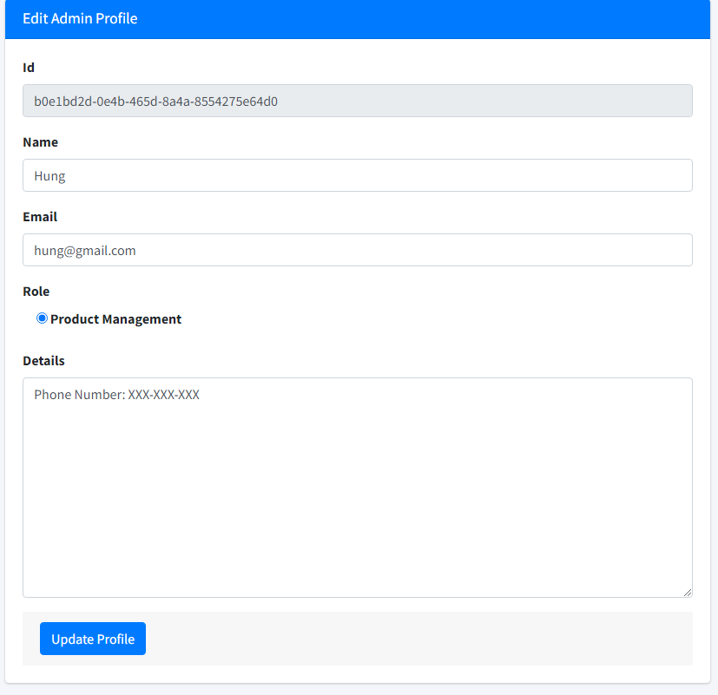

* **Purpose:** Admins can edit their information. Main admins can edit others and change roles.
* **From:** Admin profile to edit admin profile page.
* **To:** Click "Update Profile" button redirects to the admin profile page. All links from the sidebar link to other pages.
* **Description:** Admin edit profile, data update to admins table in database. These pages take information from the following tables: admins.

|  |  |  |
| --- | --- | --- |
| **Form** | **Type** | **Validation** |
| Name | Text | Not blank, unique, only letters and spaces, between 3 and 64 characters. |
| Email | Email | Not blank, unique, check email according to xxx@xxx.xxx or xxx.@xxx.xxx.xx . |
| Role | Radio button | Not blank. (only for main admin to edit) |
| Details | Textarea | Null |

## Change admin password:

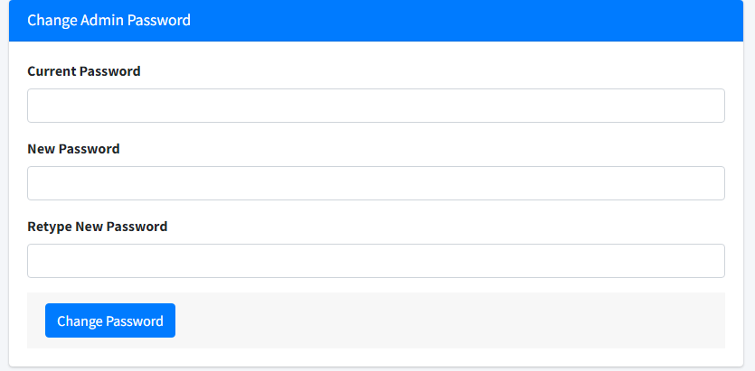

* **Purpose:** Admins can change password for their account.
* **From:** Change Password from the sidebar.
* **To:** Click “Change Password” redirects to the same page.
* **Description:** Admins can change their password and data update in the admins table. This page takes information from the following tables: admins.

|  |  |  |
| --- | --- | --- |
| **Form** | **Type** | **Validation** |
| Current Password | Password | Not blank, must be the same current password. |
| New Password | Password | Not blank, at least 8 characters, contain at least 1 number and at least 1 letter. |
| Retype New Password | Password | Not blank, must be the same new password, at least 8 characters, contain at least 1 number and at least 1 letter. |

## Customer Management:

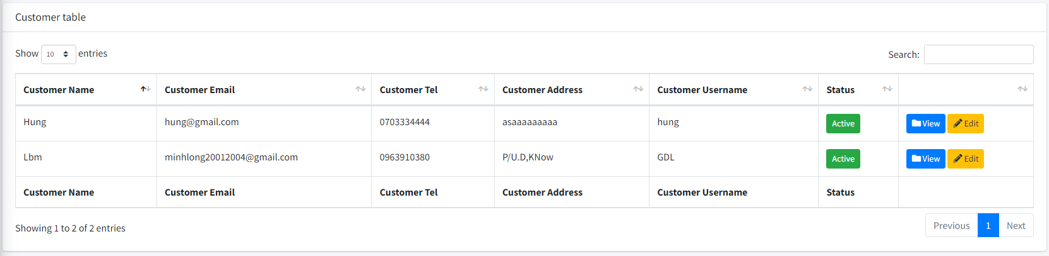

* **Purpose:** Main admin view list of customers and edit, delete customers.
* **From:** Customer management to list of customers.
* **To:** All links from the sidebar link to other pages. The “View” button redirects to Profile page. The "Edit" button redirects to the edit customer profile page.
* **Description:** These pages take information from the following tables: customers.

## Customer Profile:

* **Purpose:** Main admin view details of a customer profile.
* **From:** Customer Management.
* **To:** Click "Edit Profile" button redirects to the edit customer profile page. All links from the sidebar link to other pages.
* **Description:** These pages take information from the following tables: customers.

## Edit Customer Profile:

* **Purpose:** Admins edit a customer information.
* **From:** Customer profile.
* **To:** Click "Update Profile" button redirects to the customer profile page. All links from the sidebar link to other pages.
* **Description:** Admin edit customer profile, data update to customers table in database. These pages take information from the following tables: customers.

|  |  |  |
| --- | --- | --- |
| **Form** | **Type** | **Validation** |
| Name | Text | Not blank, only letters and spaces, between 3 and 100 characters. |
| Username | Text | Not blank, unique, only letters, digits and underscore, between 3 and 64 characters. |
| Email | Email | Not blank, unique, check email according to xxx@xxx.xxx or xxx.@xxx.xxx.xx . |
| Status | radio | Active/ Disable |
| Phone number | Number | Not blank, non-negative numbers, only 10 digits, starting from 03, 05, 07, 08 or 09. |
| Address | Text | Not blank. |

## Product List:

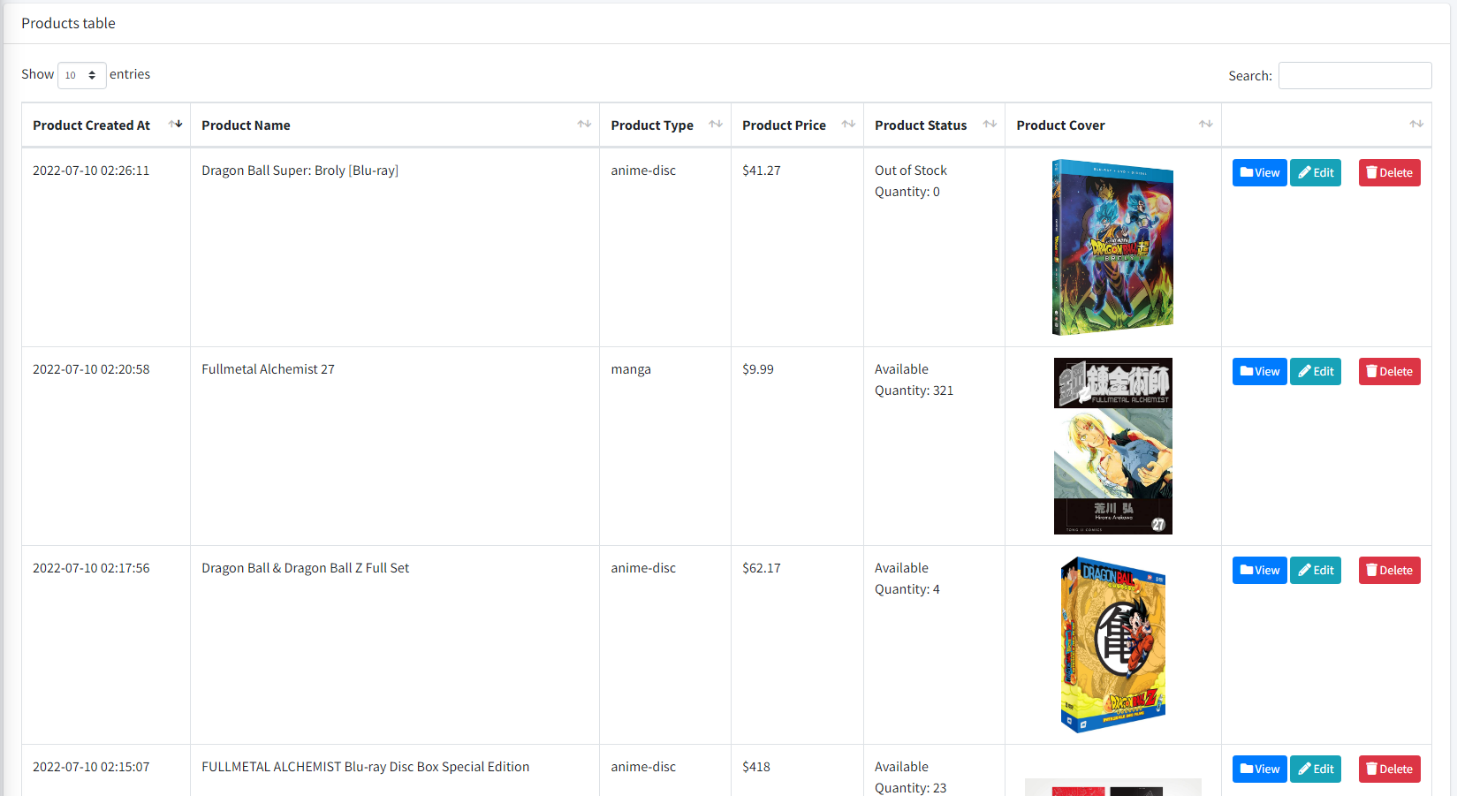

* **Purpose:** Managing products, add, view, edit, or remove products
* **From:** Side bar, index
* **To:** View/ edit product page on right-side selection
* **Description:** These pages take information from the following tables: products

## Product – create:

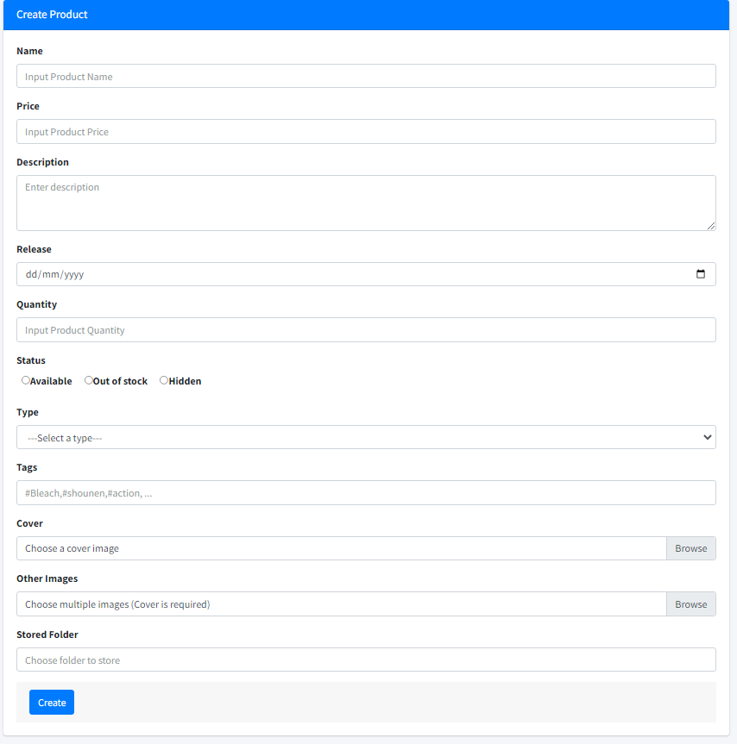

* **Purpose:** Create a new product
* **From:** Side bar
* **To:** Product list after create
* **Description:** These pages take information from the following tables: products

|  |  |  |
| --- | --- | --- |
| **Form** | **Type** | **Validation** |
| Name | text | Not blank, unique, only letters and spaces, between 3 and 100 characters. |
| Price | number | Not blank. |
| Description | textarea | Null |
| Release | date | Null |
| Quantity | number | Not blank. |
| Status | radio | Available/ Unavailable |
| Type | option | manga/anime/figure/merchandise |
| Tags | text | Tags to search, between “#” and “,” |
| cover | image file | Not null |
| images | file multiple | Null |

## Product – View:

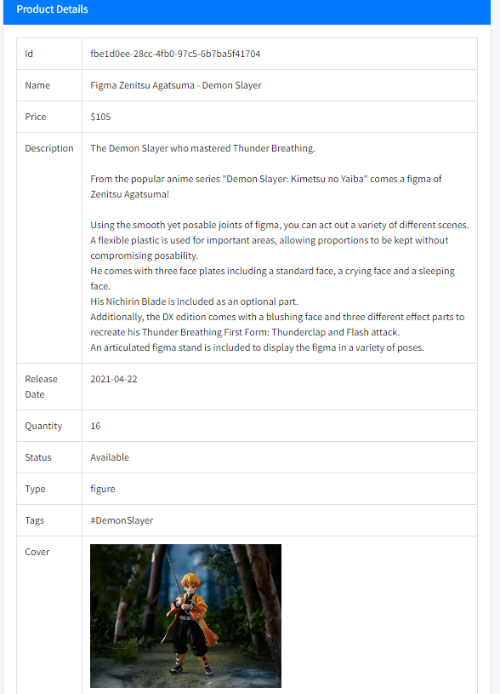

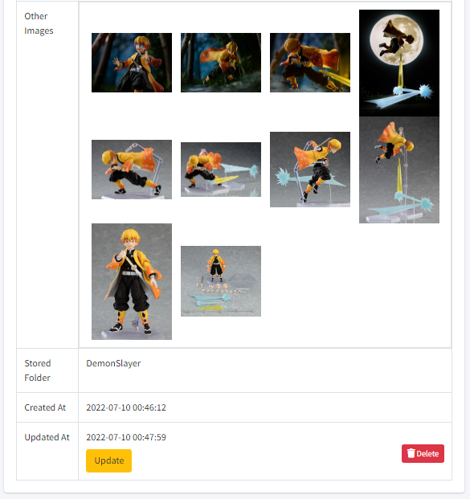

* **Purpose:** View details of product, has option to update or delete product
* **From:** Product list – view button
* **To:** Edit product. Delete product will redirect to product index
* **Description:** These pages take information from the following tables: products

## Product Edit:

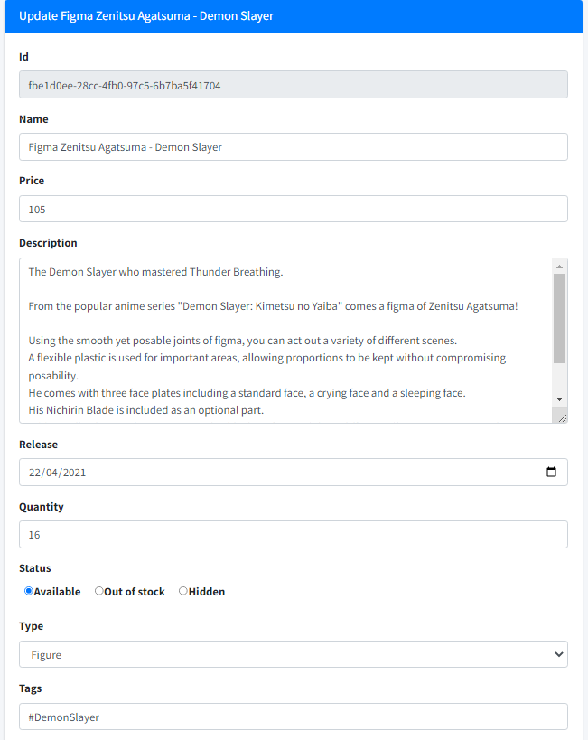

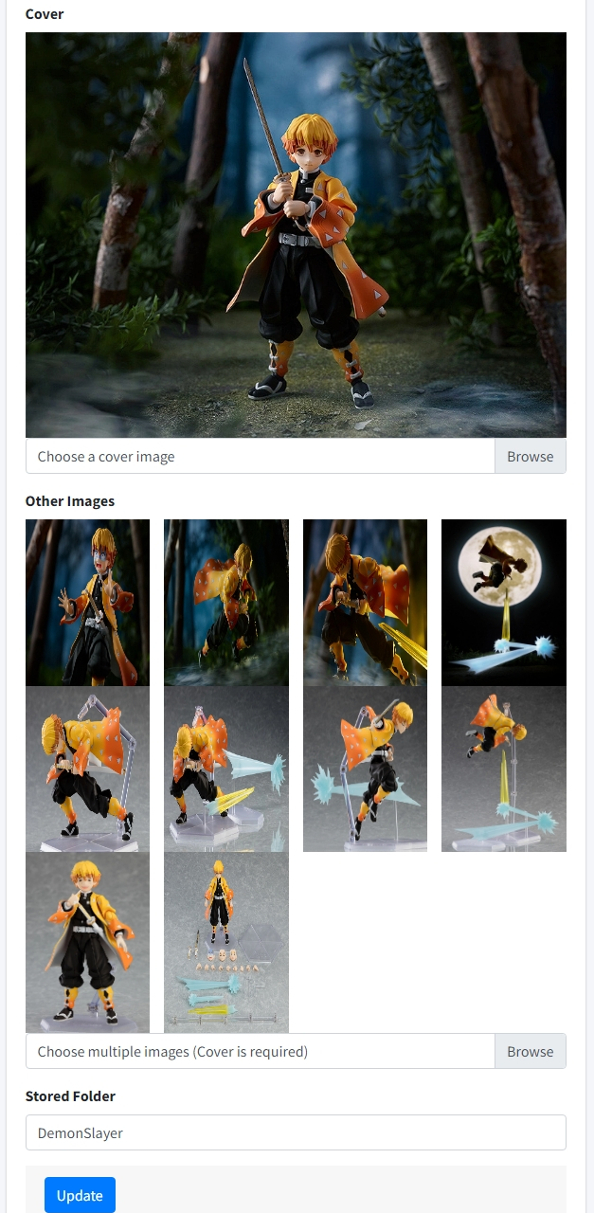

* **Purpose:** Edit details of product
* **From:** Product list – edit button, Product view – Update button
* **To:** After update, return to view page
* **Description:** These pages take information from the following tables: products

## Order page:

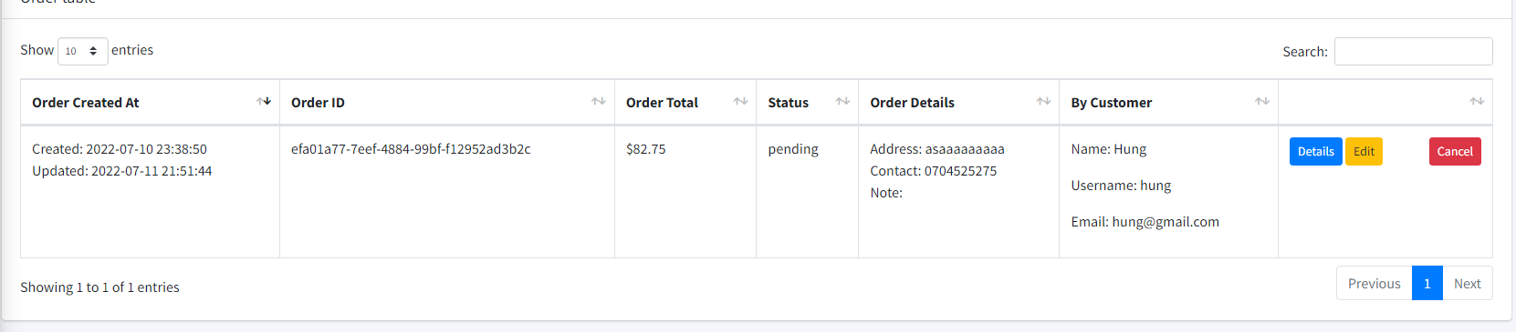

* **Purpose:** Managing orders, view, approve, update orders’ status
* **From:** Side bar
* **To:** Order details, order update
* **Description:** These pages take information from the following tables: order, orderdetails

## Order details:

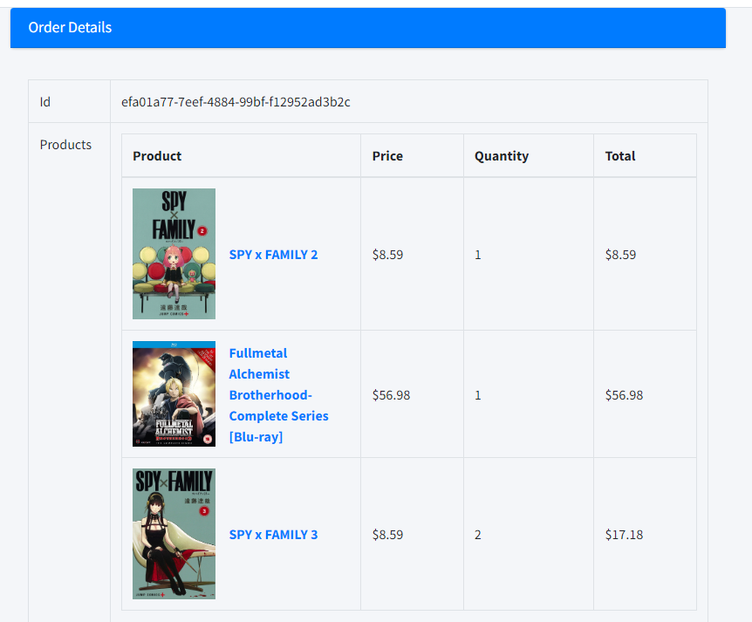

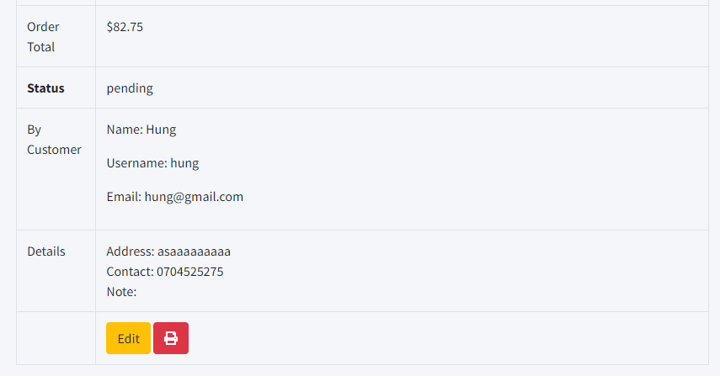

* **Purpose:** Show order details
* **From:** Oder page
* **To:** Order update
* **Description:** These pages take information from the following tables: order, order details

## Order Update

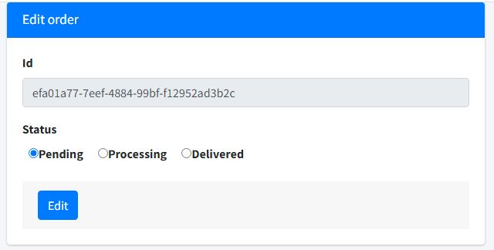

* **Purpose:** Update order status
* **From:** Oder list, order details
* **To:** Order update
* **Description:** These pages take information from the following tables: order, order details

## Comment list:

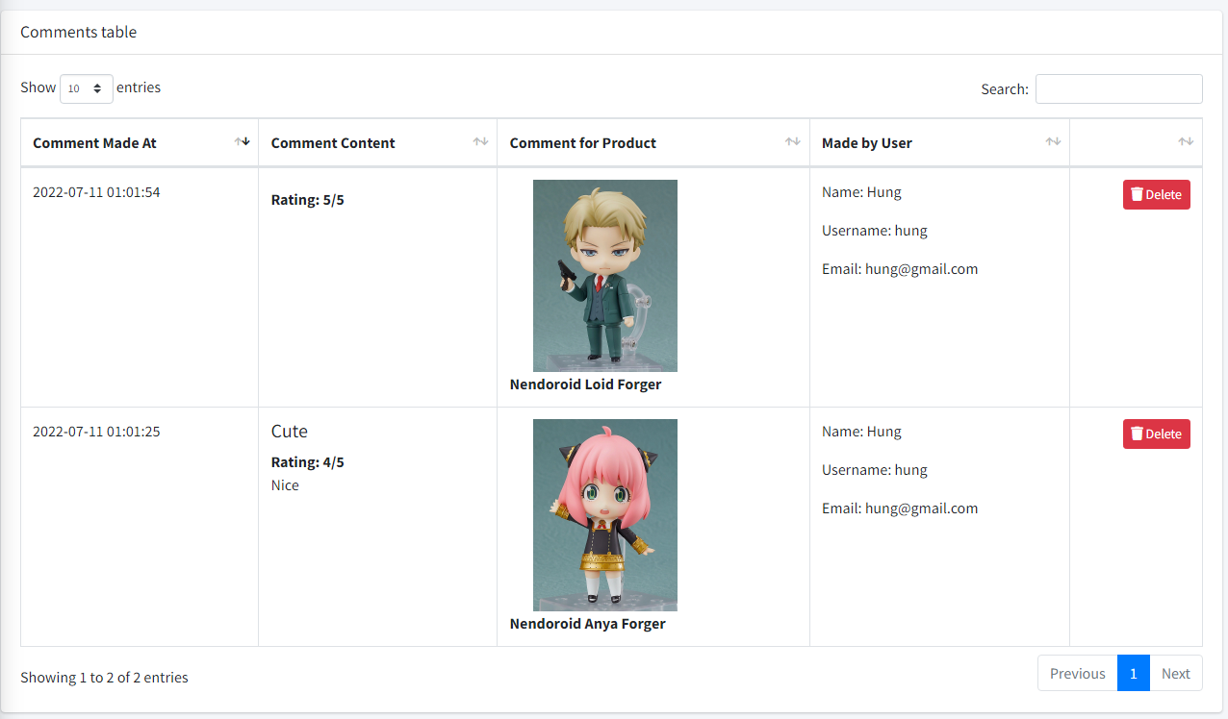

* **Purpose:** Show customers’ comment list, enable delete comment
* **From:** Side bar link, index
* **Description:** These pages take information from the following tables: comments, products, customers

## Feedback:

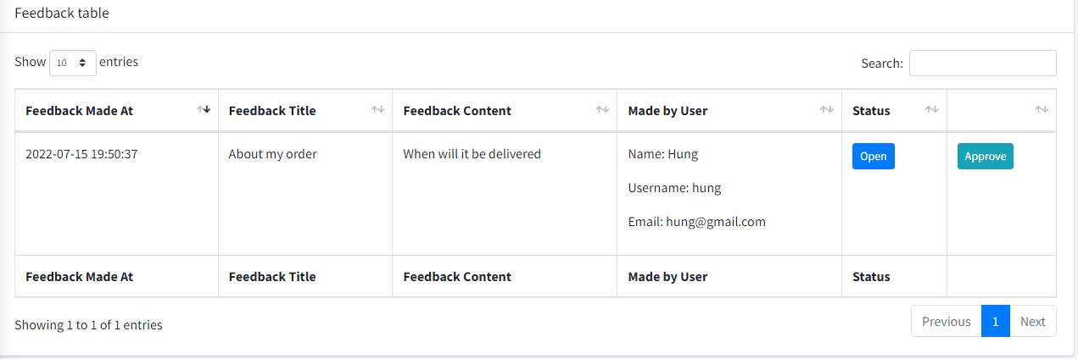

* **Purpose:** Show customers’ feedbacks, admin can checked the feedback as answered (Approve)
* **From:** Side bar link, index
* **To:** Feedback update
* **Description:** These pages take information from the following tables: feedbacks, customers

## Promotion Management:

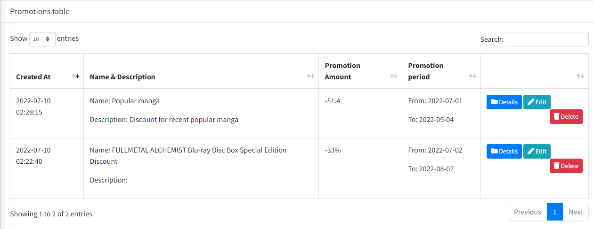

* **Purpose:** Managing promotions, add, view, update, delete promotion
* **From:** Side bar, index
* **To:** Promotion view/edit
* **Description:** These pages take information from the following tables: promotion, products

## Promotion create:

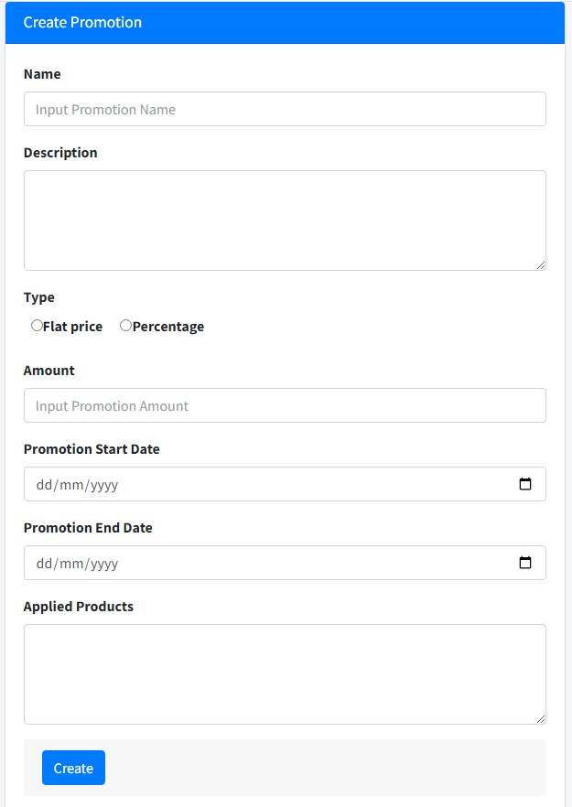

* **Purpose:** Create promotion
* **From:**  Side bar
* **To:** Promotion list after create
* **Description:** These pages take information from the following tables: promotion, products

## Promotion view:

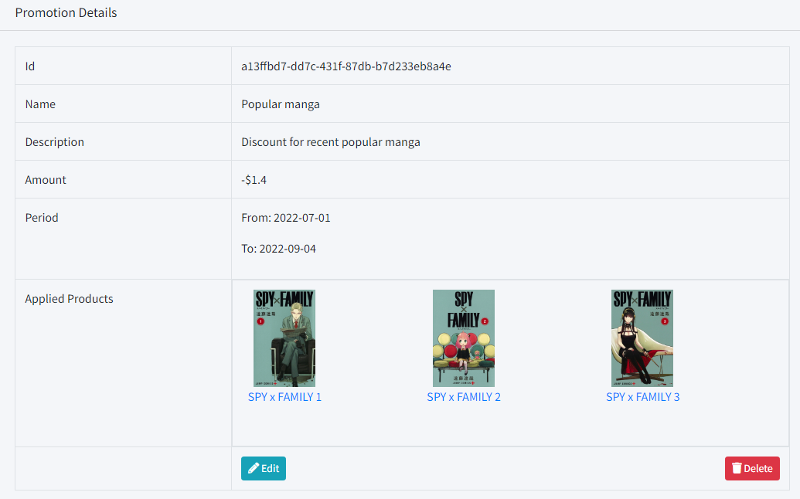

* **Purpose:** View promotion
* **From:**  Side bar/ promotion list
* **To:** Promotion edit
* **Description:** These pages take information from the following tables: promotion, products

## Promotion edit:

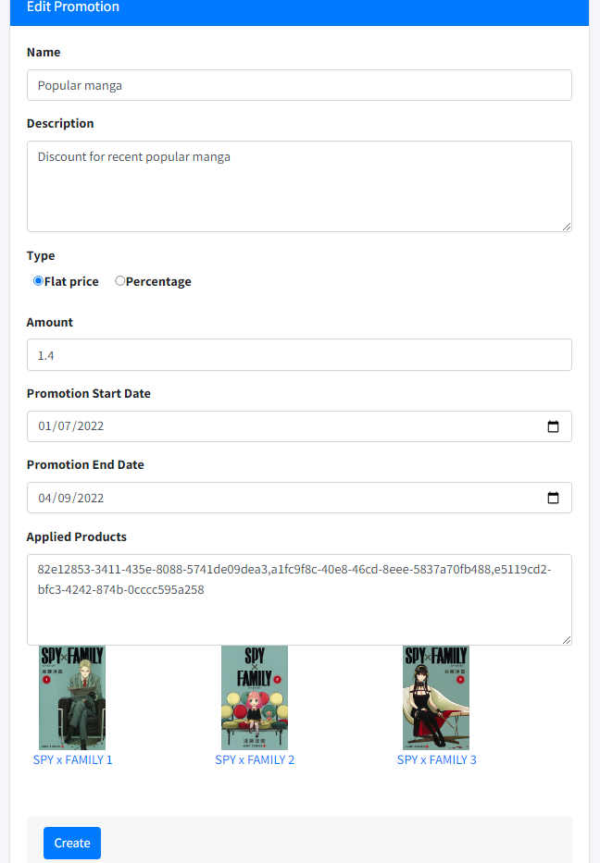

* **Purpose:** Edit promotion
* **From:**  Promotion list/ promotion view
* **To:** Promotion view after edit
* **Description:** These pages take information from the following tables: promotion, products

## News:

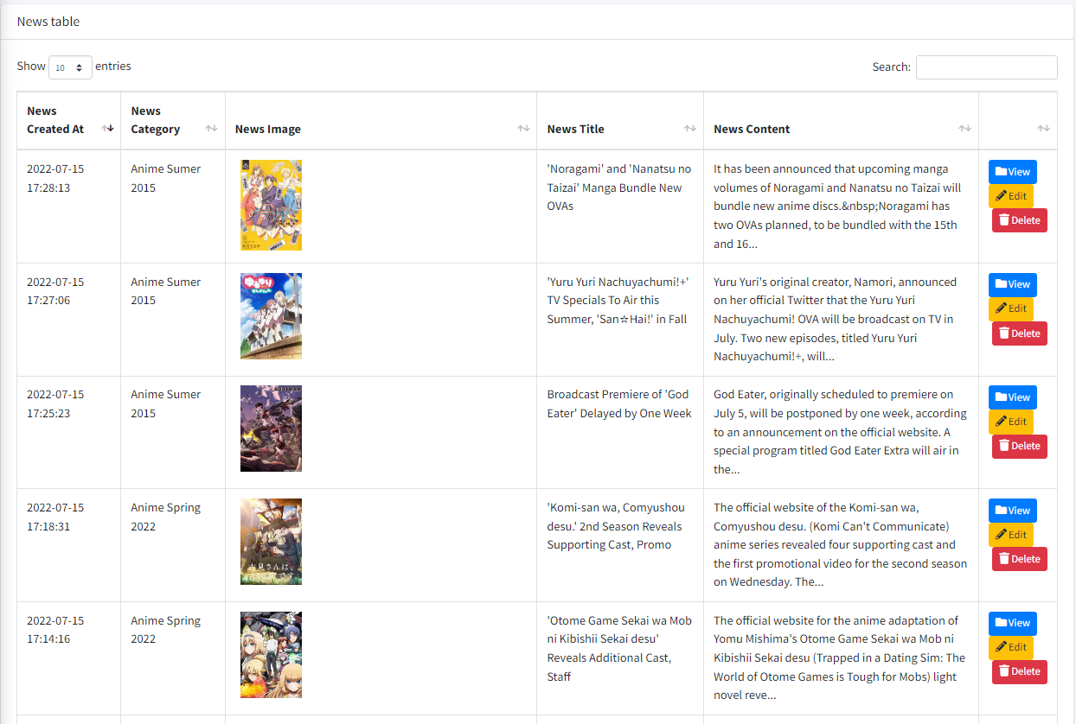

* **Purpose:** Managing news, add, view, update, delete news
* **From:** Side bar
* **To:** news view/edit
* **Description:** These pages take information from the following tables: news

## News - Create:

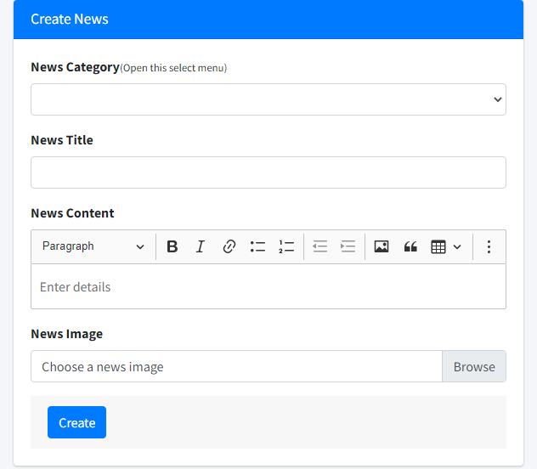

* **Purpose:** Create news
* **From:** Side bar
* **To:** New list
* **Description:** These pages take information from the following tables: news

|  |  |  |
| --- | --- | --- |
| **Form** | **Type** | **Validation** |
| New Category | select | Not blank. |
| New Title | text | Not blank, unique |
| New Content | textarea | Not blank, unique |
| New Image | file | Not null |

## News - view:

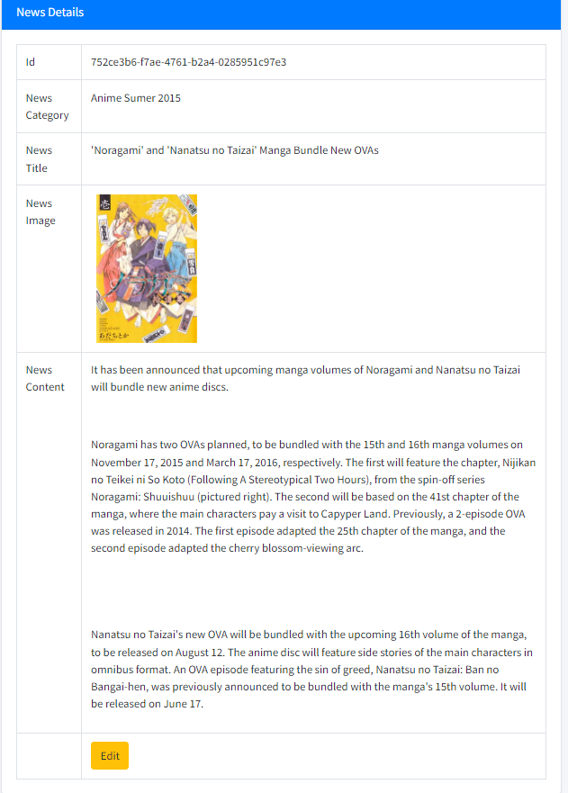

* **Purpose:** View news
* **From:** News list
* **To:** Edit news
* **Description:** These pages take information from the following tables: news

## News - Edit:

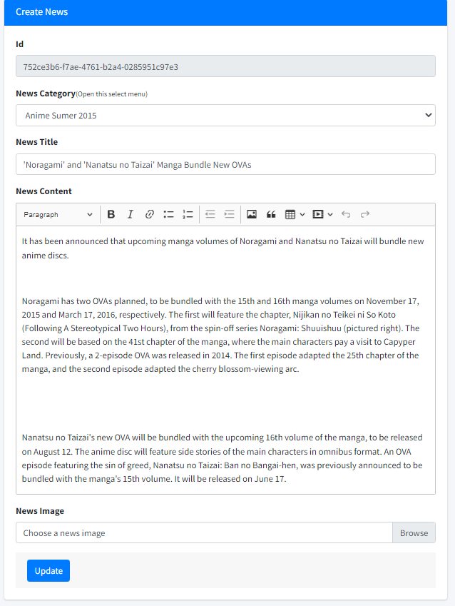

* **Purpose:** Edit news
* **From:** News list/ News view
* **To:** News view after edit
* **Description:** These pages take information from the following tables: news

|  |  |  |
| --- | --- | --- |
| **Form** | **Type** | **Validation** |
| New Category | select | Not blank. |
| New Title | text | Not blank, unique |
| New Content | textarea | Not blank, unique |
| New Image | file | Null |

## Contact Management:

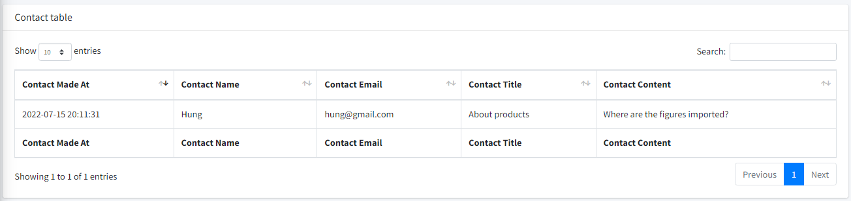

* **Purpose:** Contact management
* **From:** Sidebar link, index
* **Description:** These pages take information from the following tables: contact

## Q&A Management:

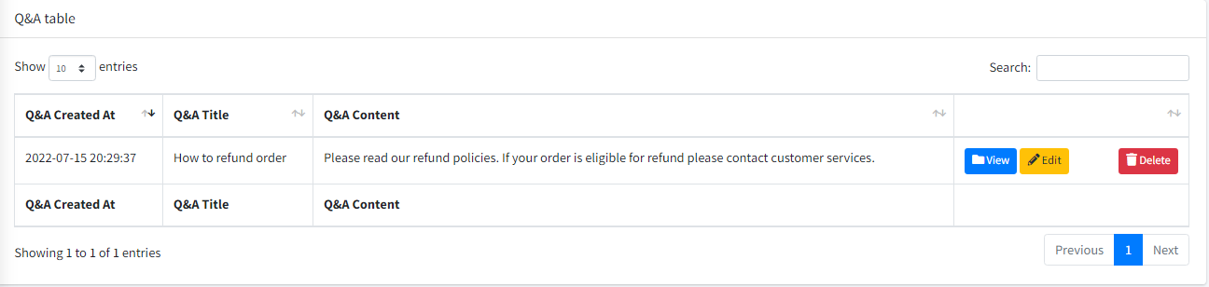

* **Purpose:** Manage q
* **From:** Sidebar link, index
* **Description:** These pages take information from the following tables: q_a

## Q&A Create:

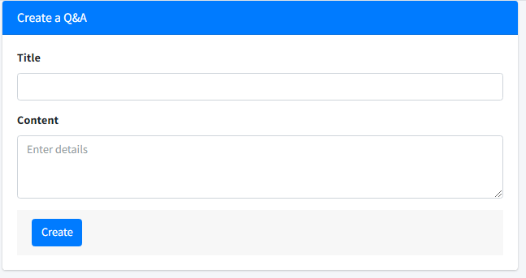

* **Purpose:** Create q&a
* **From:** Sidebar link, index
* **Description:** These pages take information from the following tables: q_a

|  |  |  |
| --- | --- | --- |
| **Form** | **Type** | **Validation** |
| Title | text | Not blank, unique |
| Content | textarea | Not blank, unique |

1. 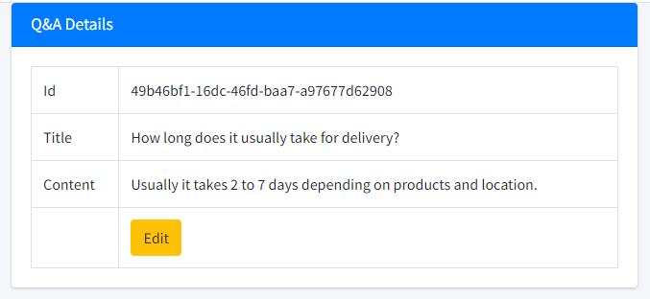**Q&A Details**

* **Purpose:** View q&a
* **From:** q&a list
* **To:** edit q&a
* **Description:** These pages take information from the following tables: q_a

1. 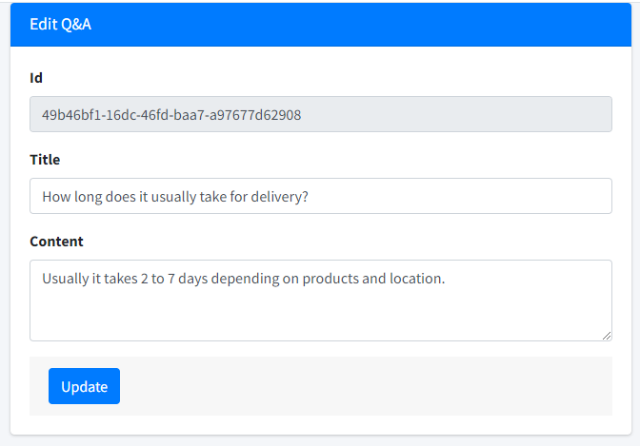**Q&A – Edit**

* **Purpose:** upadate q&a
* **From:** edit q&a/ q&a view
* **To:** q&a view after edit
* **Description:** These pages take information from the following tables: q_a

|  |  |  |
| --- | --- | --- |
| **Form** | **Type** | **Validation** |
| Title | text | Not blank, unique |
| Content | textarea | Not blank, unique |

## Print invoice

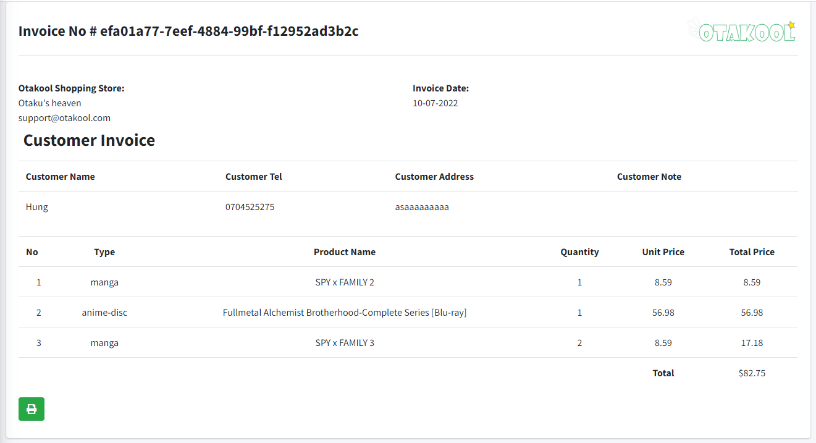

* **Purpose:** Print invoice
* **From:** edit order
* **Description:** These pages take information from the following tables: customers, orders, orderdetails, products

# Task Sheet Review 3

|  |  |  |  |  |  |
| --- | --- | --- | --- | --- | --- |
| **Members Group** | | **Date Preparation of Activity Plan** | | | |
| **No** | **Name** | **Description Task** | **Start Date** | **End Date** | **Status** |
| 1 | Đào Bùi Quang Hưng | FE: home page, header, product list, product details, comment  BE: index page, product management, comments management | 15/06/2022 | 22/06/2022 | Completed |
| 2 | Nguyễn Hoài Thương | FE: order, shopping cart, shopping history  BE: order management | 15/06/2022 | 22/06/2022 | Completed |
| 3 | Nguyễn Ngọc Kim Ngân | FE: footer, customer register, customer profile, Q&A, contact  BE: admin management, customer management, Q&A management, contact management | 15/06/2022 | 22/06/2022 | Completed |
| 4 | Lã Bảo Minh | FE: feedback, promotion, news  BE: feedbacks management, promotions management, news management | 15/06/2022 | 22/06/2022 | Completed |
|  | | | | | |
| **Teacher** | | | **Team Leader** | | |
|  | | |  | | |
| **Đào Ngọc Anh** | | | **Đào Bùi Quang Hưng** | | |